Edwin Walter Soldner
November 28, 1890 – May 29, 1892

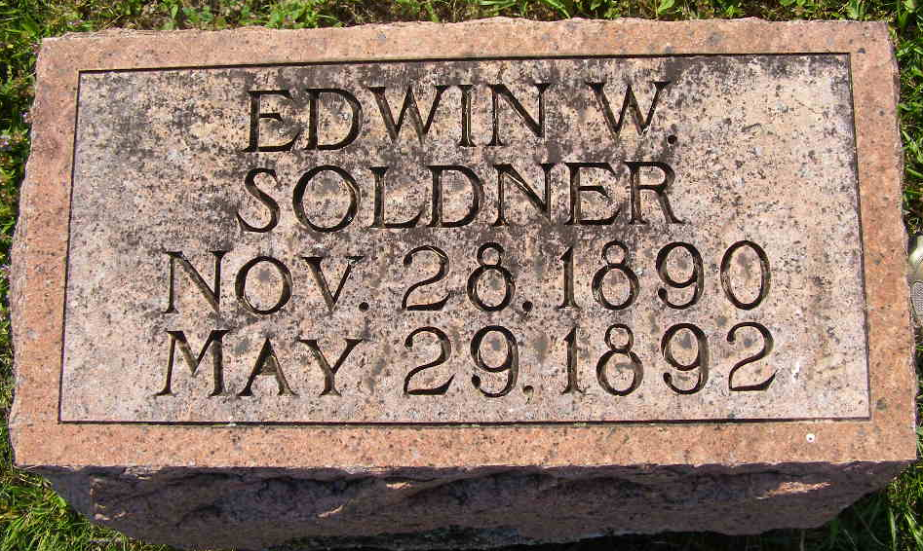
Photo by Shaunda Bedwell Opdycke

Edwin Walter Soldner from tree Ballentine/Soldner Family Tree

Birth 28 Nov 1890 Berne, Adams, Indiana, USA
Death 29 May 1892 Berne, Adams, Indiana, USA
Father Peter Soldner (1860-1921)
Mother Mary Ann Luginbill (1863-1891)
772 People 0 Records 2 Sources
**

Web: RootsWeb Cemetery Index, 1800-2010

Name Edwin W Soldner
Birth Date 1890
Death Date 1892
Burial Place Adams, Indiana, USA
Cemetery M.R.E. Cemetery

