Dora M. Soldner
September 7, 1886 – February 21, 1976

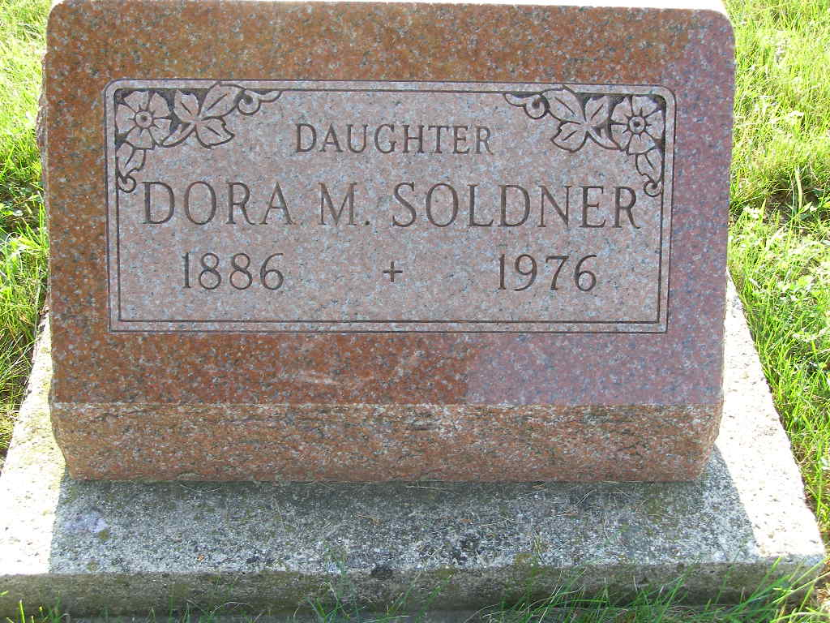
Photo by Shaunda Bedwell Opdycke

Dora M. Soldner, 88, died at 10:25 p.m. Sunday at Swiss Village in Berne, where she had resided the past six years. She had been ill approximately two years. Death was attributed to complications.
Born in Monroe Township, Adams County, on September 7, 1887 [sic], she was the daughter of David and Anna Wulliman-Soldner, was a retired professor of German literature and theology, and taught at the following schools: Freeman Junion College, Freeman, S.D.; Wheaton College, Wheaton, Ill.; Bluffton College, Bluffton, O.; and Kings College, Briarcliff (cut off)

Decatur Daily Democrat, Adams County, Indiana
Monday, February 23, 1976
**

RETIRED COLLEGE PROFESSOR DIES

Berne, Ind. – Funeral services for Dora M. Soldner, 89, a retired college professor German, was held at Yager Funeral home here on Wednesday morning, Feb. 25, with Rev. Kenneth Bauman, pastor of the Berne First Mennonite Church of which she was a member, officiating.
Miss Soldner, who had resided at Swiss Village here the past six years, taught at Freeman (S.D.) Junior College, Wheaton (Ill.) College, Bluffton (Ohio) College and The King’s college, Briarcliff Manor, N. Y.
A 1918 graduate of Bluffton College, she received the M. A. degree in German literature and philosophy from Indiana University in 1926.

Unnamed Newton, Kansas newspaper clipping
March 4, 1976

