David Soldner
Mary 24, 1853 – April 3, 1937
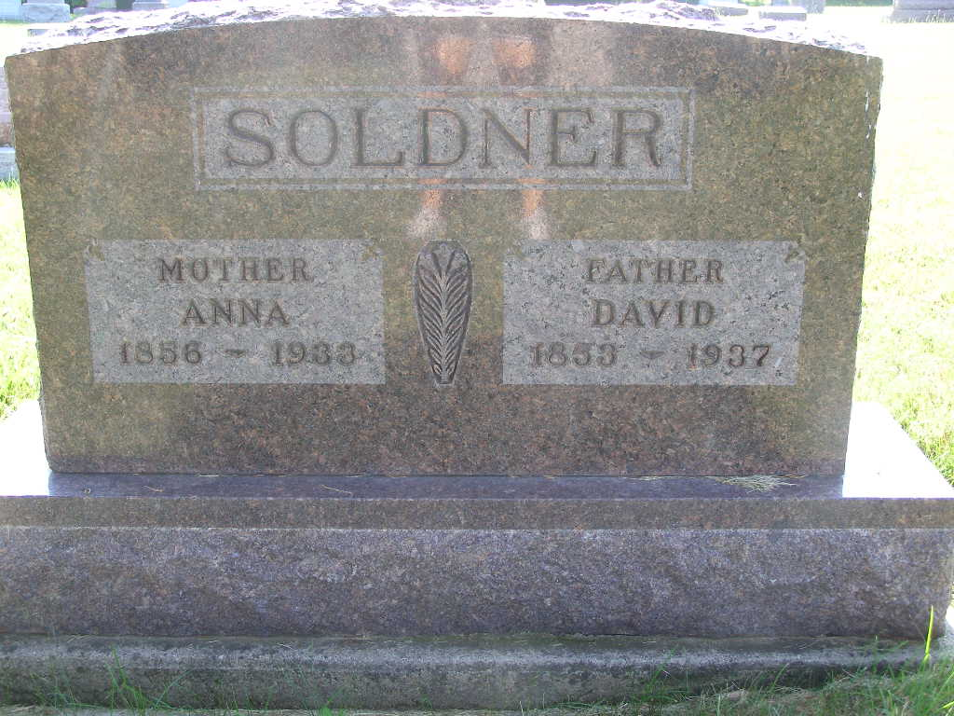
Photo by Shaunda Bedwell Opdycke

DAVID SOLDNER DIES SATURDAY AT FARM HOME - Aged Retired Monroe Township Farmer Dies; Funeral Tuesday
David Soldner, aged 83, pioneer retired farmer and one of the best known men of this community, died at 7:05 o'clock Saturday evening at his home 2 miles north and one and one-half miles west of Berne. Mr. Soldner had been making his home with his son, Clinton and family.
Death was caused by infirmities and complications. He had been ailing for two years and was bedfast the last ten weeks. He suffered a broken leg some time ago in an accident and this is believed to have hastened his death. His condition had been critical several days before his death.
Mr. Soldner was born in Wabash township, May 24, 1853, a son of John and Mary Stauffer Soldner. He grew to manhood on his father's farm and early in life married Miss Anna Wulliman. She died several years ago. Following their marriage, the couple lived in Hartford township for some time, then moved to Monroe township where Mr. Soldner resided on the same farm for the last 56 years. He was for many years recognized as one of the outstanding farmers in the county.
Surviving are the following children: Mrs. Edna Stauffer and Mrs. Noah (Ida) Luginbill, both of Berne; Mrs. Edwin (Bertha) Lehman, Wabash twp.; Mrs. Maria Neuenschwander, Berne; Miss Dor?? Soldner, an instructor at Wheaton College, Wheaton, Ill.; Mrs. Edwin (Zilla) Amstutz, Bluffton, O.; and Clinton Soldner, on the home place in Monroe township.
One sister, Mrs. Barbara P. Lehman, of Berne, and one brother, Jonas Soldner, of Fresno, Calif. survive, also twenty grandchildren and eight great-grandchildren. One son, Albert, and the following brothers and sisters preceded: John, Sam, Peter, Fanny and Mar?? Baumgartner.
Mr. Soldner was a member of the Mennonite church. The funeral will be held Tuesday afternoon at 1:30 o'clock at the home and at ? o'clock at the Mennonite church here, Rev. C. H. Suckau officiating. Burial will be in the M.R.E. cemetery.

Adams County (IN) Historical Museum
1937 Scrapbook, image 067
Handwritten: Monday, April 5, 1937

