Clinton David Soldner
May 4, 1897 – February 22, 1974
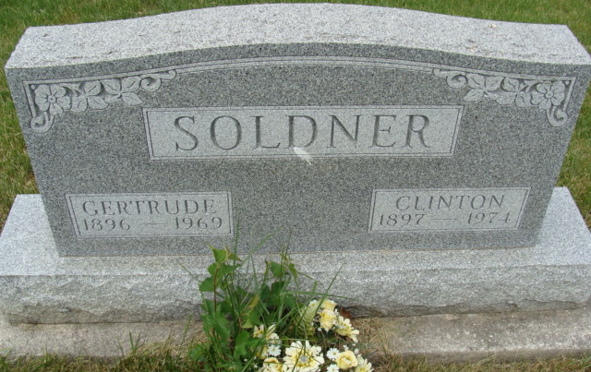
Photo by Alicia Kneuss

Clinton Soldner dies at Berne
Clinton D. Soldner, 76, a retired farmer and milk plant employee, died at 8:30 p.m. Friday at Swiss Village. He had been ill three days. He was a member of the First Mennonite Church.
Born in Monroe township on May 4, 1897, he was the son of David and Anna Wulliman-Soldner, and was married to Gertrude Lehman, who preceded him in death.
Surviving are two children, Miss Janet Soldner, a missionary in Mexico, and Mrs. Roger (Treva) Schaffter, of route 1, Berne; one sister, Miss Dora Soldner of Berne; two grandchildren and five great-grandchildren.
Funeral services will be held at 10:30 a.m. Monday at the Yager funeral home, with Rev. Vernon Sprunger officiating. Burial will be in the M.R.E. cemetery. Friends may call at the funeral home after 11 a.m. Saturday

Decatur Daily Democrat, Adams County, Indiana
Saturday, February 23, 1974

