Catharina (Huser) Soldner
November 6, 1853 – March 23, 1929
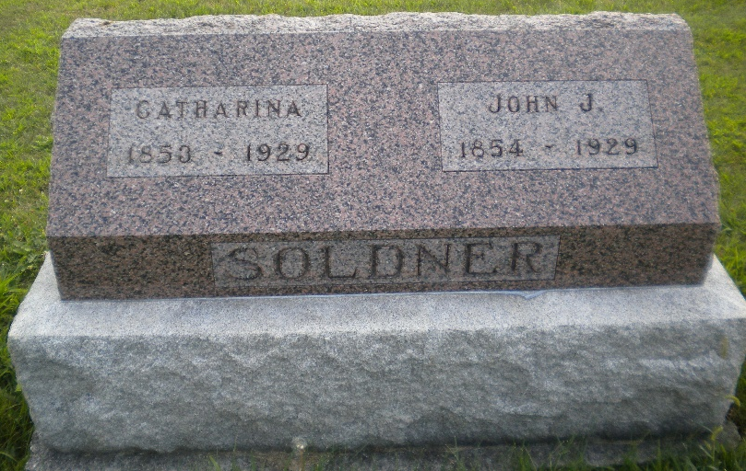
Photo by DSON1492

Indiana, Death Certificates, 1899-2011
Name Catharine Soldner
[Caterine Huser]
Gender Female
Race White
Age 75y 4m 17d
Marital Status Widowed
Birth Date 6 Nov 1853
Birth Place Indiana
Death Date 23 Mar 1929
Death Place Monroe, Adams, Indiana, USA
Death Registration Date 1929
Father Philip Huser
Mother Fanny Moser I have mother as Verena Moser (no parents)
Spouse John J Soldner (deceased)
Informant John C. Soldner, Berne, Ind.
Burial M.R.E. Cemetery 3-26-1929

