Anna (Wulliman) Soldner
March 30, 1856 – February 3, 1933
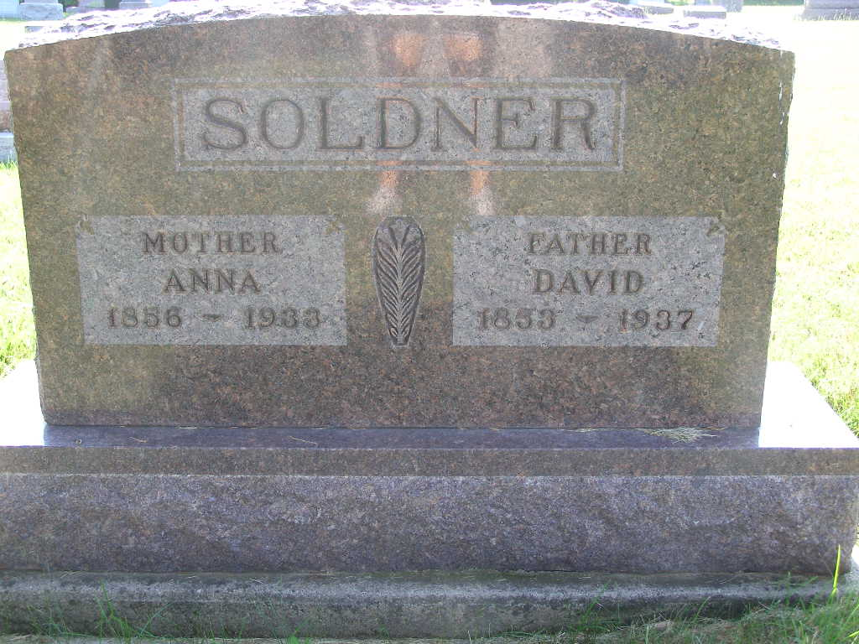
Photo by Shaunda Bedwell Opdycke

Indiana, U.S., Death Certificates, 1899-2017

Name Mrs Anna Soldner
[Mrs Anna Wulliman]
Gender Female
Race White
Marital Status Married
Age 76y 10m 3d
Birth Date 30 Mar 1856
Birth Place Indiana
Death Date 3 Feb 1933
Death Place Berne, Adams, Indiana, USA
Death Registration Date 1933
Father Clemens Wulliman b. Switzerland
Mother Elizabeth Habegger b. Switzerland
Spouse David Soldner, informant
Burial M.R.E. Cemetery 2-5-1933

