Albert E. Soldner
December 30, 1880 – May 9, 1883
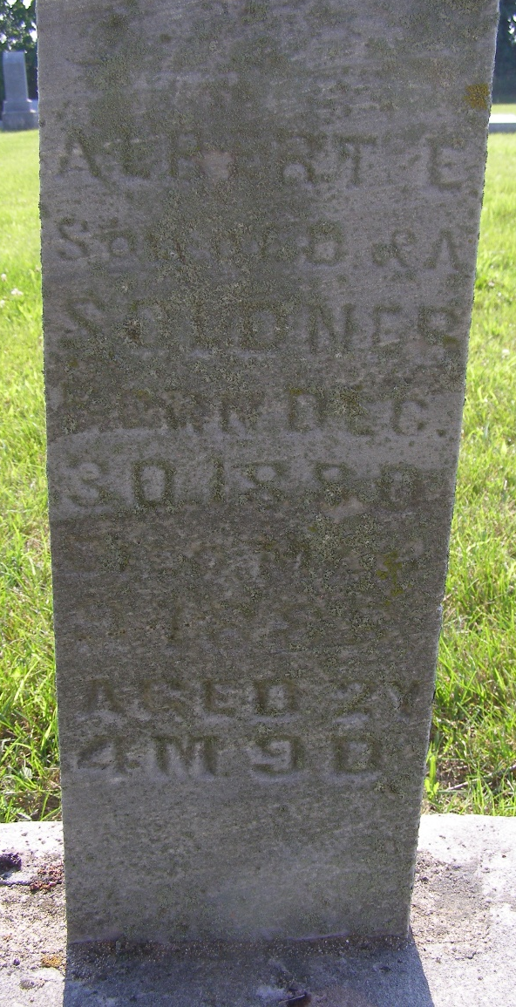
Photo by Shaunda Bedwell Opdycke

Indiana, U.S., WPA Death Index, 1882-1920

Name Albert Soldner
Date May 09, 1883
Location Monroe Township
Age 2 Yr
Gender Male
Race White
Source location County Health Office, Decatur
Source notes The source of this record is the book H-19 on page 26 within the series produced by the Indiana Works Progress Administration.

