Marggie (Flores) Solano
June 3, 1923 - May 15, 2012

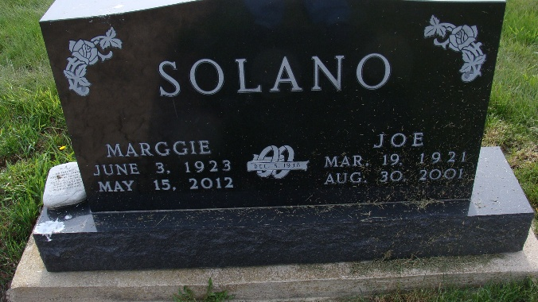
Photo by Alicia Kneuss

Marggie Solano, 89, Berne, passed away Tuesday, May 15, 2012 at her home. She was the daughter of Louis and Julia(Alonzo) Flores born on June 3, 1923 in Moore, Okla. She married Joe Solano on December 5, 1938 who is deceased.
She was a member of the Trinity United Methodist Church. She was a former employee of Smith Bros. of Berne as a seamstress and retired from CTS Corp with 25 years of service. Special interests included: crocheting, knitting, and collecting antique cars. She was an avid Indy Pacer fan and enjoyed attending car shows.
Survivors include: a daughter, Mary Ann (Joe) Tilbury, Berne and sons, David (Pauline) Solano, Riverside, California, and Ruben (Janet) Solano, Berne. Also 10 grandchildren, 17 great-grandchildren, and 6 great,great-grandchildren.
Deceased are her husband, parents, and 2 brothers and 3 sisters.
Funeral services are Saturday, May 19 at 10:30am at the Trinity United Methodist Church with visitation 1 hour prior to services. Visitation on Friday from 4 to 8 pm at the Yager-Kirchhofer Funeral Home. Officiating are Pastors Mark Harris and Dr. Wayne Steury.
Burial at the MRE Cemetery.
Preferred memorials are to Family LifeCare.

Zwick & Jahn Funeral Home, Adams County, Indiana

