Joe Salano
March 19, 1921 – August 30, 2001

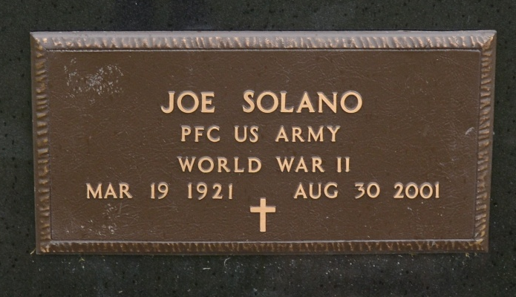
Photo by Deb Curry

Joe Solano, 80, of Berne, owner of Joe's Antiques, died Thursday, Aug. 30, 2001, at Chalet Village. The Guadalajara, Mexico, native had owned several businesses, had worked for CTS Corp. for 17 years and had served on the Berne Democratic Committee for several years. He attended Trinity United Methodist Church and was a World War II Army veteran.
Surviving are his wife, Marggie; sons David D. of Riverside, Calif., and Ruben J. of Berne; a daughter, Mary Ann Solano-Tilbury of Fort Wayne; two sisters, both of Mexico; 11 grandchildren; 10 great-grandchildren; and one great-great-grandchild.
Services are 2 p.m. Sunday at Trinity United Methodist Church, Berne, with calling one hour before services. Calling is also from 2 to 8 p.m. today at Yager-Kirchhofer Funeral Home, Berne. Burial with military graveside services by American Legion Post 468 will be at MRE Cemetery.
Memorials are to the church Memorial Fund. Information provided by Yager-Kirchhofer Funeral Home, Berne, 1-219-589-3101.

News-Sentinel, The (Allen County, Indiana)
Saturday, September 1, 2001

