Shiloh Marie (Michaud) Snyder
January 18, 1896 – February 28, 1972

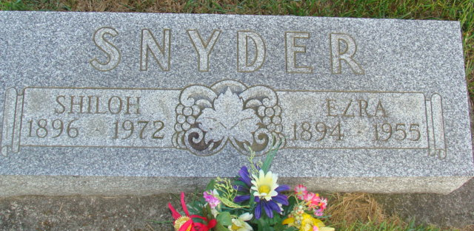
Photo by Alicia Kneuss

Widow of Ezra Snyder, 76, Dies Monday Evening
Funeral Thursday for Shiloh M. Snyder of this City
Mrs. Shiloh M. Snyder, 76, of Hilltop Apartments, 376 Jefferson Street, Berne, died at 7:10 pm Monday at the Adams County Memorial Hospital. She had been in failing health.
She was born in Berne January 18, 1896, a daughter of Anthony and Neva Harris-Michaud, and was married to Ezra W. Snyder in January of 1915. Her husband, a longtime school teacher preceded her in death in 1956.
Surviving are one daughter, Mrs. Roy (Jeanne) Gibson of Yoder Route 1; and one grandchild. One brother, Chester T. Michaud, is deceased.
Funeral services will be conducted at 10:30 am Thursday at the Winteregg-Linn Funeral Home in Decatur, with Rev. Cloyce C. Cunningham officiating. Burial will be in the MRE Cemetery. Friends may call at the funeral home until time of the services.

Date of Death: February 29, 1972; Date of Burial: March 2, 1972
Burial: S ½ 28, Section 3, 4th Addition
Berne Heritage Room
MRE obits 1966 - 1972

