Ezra W. Snyder
May 21, 1894 – July 25, 1955

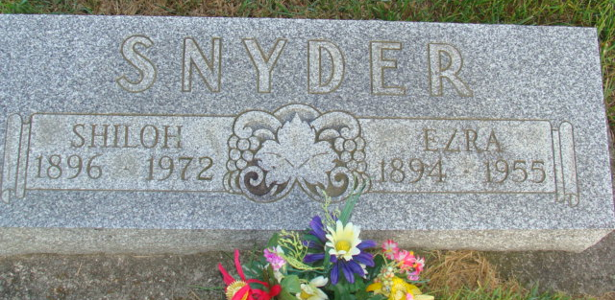
Photo by Alicia Kneuss

Indiana, U.S., Death Certificates, 1899-2017

Name Ezra W Snyder
Gender Male
Race White
Marital Status Married
Age 61
Birth Date 21 May 1894
Birth Place Hartford Township
Death Date 24 Jul 1955
Death Place Berne, Adams, Indiana, USA
Death Registration Date 1955
Father John Snyder
Mother Katherine Fliginger
Informant not named
Burial 7/27/1955 M.R.E.

