Devona (Schlagenhauf) Snyder
June 15, 1904 – May 23, 1989

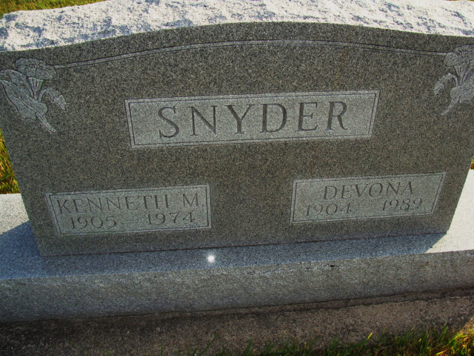
Photo by Alicia Kneuss

Indiana, U.S., Death Certificates, 1899-2017

Name Devana Snyder
[Devana Schlagenhaus]
Gender Female
Race White
Marital Status Widowed
Age 84
Birth Date 5 Jun 1904
Birth Place Adams County, Indiana
Death Date 23 May 1989
Death Place Berne, Adams, Indiana, USA
Death Registration Date 1989
Father Edwin Schlagenhaus
Mother Bertha Liddy
Informant Lawrence O. Moeller, adm.
Disposition 5/25/1989 Ft. Wayne Crematory; 5/26/1989 M.R.E.

