William Philip Smith
August 6, 1882 – March 13, 1922

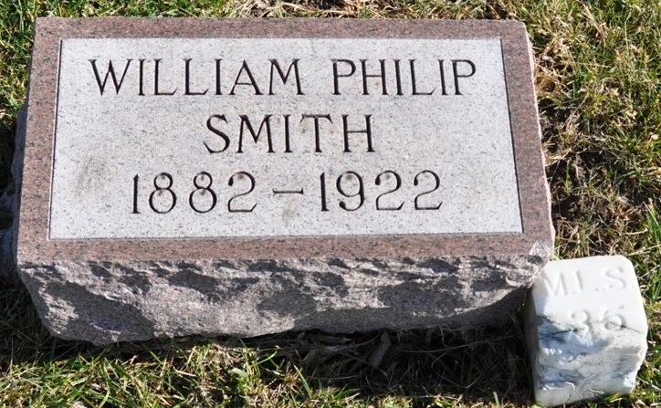
Photo by Deb Curry

Indiana, U.S., Death Certificates, 1899-2017

Name Wm Phillip Smith
Gender Male
Race White
Marital Status Single
Age 39
Birth Date abt 1883
Birth Place Indiana
Death Date 12 Mar 1922
Death Place New Castle, Henry, Indiana, USA
Death Registration Date 1922
Father M. L. Smith
Mother Drusilla Kern
Informant C.A. Marsh, New Castle, IN
Burial Berne, Ind. 3/14/1922

