William Mac Smith
June 28, 1935 – March 4, 2010

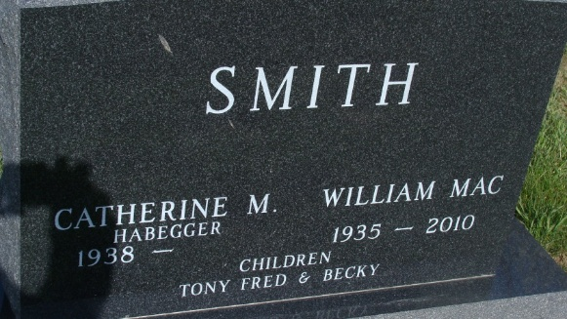
Photo by Alicia Kneuss
WILLIAM "MAC" SMITH, 74, of Geneva, passed away Thursday, March 4, 2010, near Geneva, Ind. Born June 28, 1935, in Adams County, he was the son of the late Godfred William and Laura Opal Smith. He married Catherine M. Habegger on Oct. 14, 1956; she survives of Geneva.
He was a member of First Mennonite Church of Berne. He was an accomplished mason and master craftsman. He was a member of International Union of Bricklayers and Allied Craft Workers. He was also a member of the Loyal Workers Sunday School Class. He loved to travel, enjoyed hunting and fishing, and was an avid gardener.
Also surviving are his sons, Tony Smith of Indianapolis and Fred (Lori) Smith of Fishers; daughter, Becky (Kent) Werst of Geneva; and grandchildren, Michael and Jessica Smith, Parker and Logan Smith, and Jackson, Jacob, and Isaac Werst; brothers, Harold and Tim Smith; and sisters, Grace Whetstone and Veda Edwart.
He was preceded in death by siblings, Catherine Summers, Mildred Boice, Jane Knipstein, Walter Smith, and Harry Smith.
Funeral service is 10:30 a.m. Monday, March 8, 2010, at First Mennonite Church, Berne, with calling one hour prior. The Rev. Jerry Flueckiger officiating. Family and friends will be received from 1 to 8 p.m. Sunday, March 7, 2010, at Yager-Kirchhofer Funeral Home, Berne. Interment in M.R.E. Cemetery of rural Berne.
Preferred memorials to First Mennonite Church Missions. Arrangements by Yager-Kirchhofer Funeral Home, Berne.

Fort Wayne (Allen County, IN) newspapers
March 6, 2010

