Velma M. (Opliger) Smith
February 18, 1907 – August 4, 2001
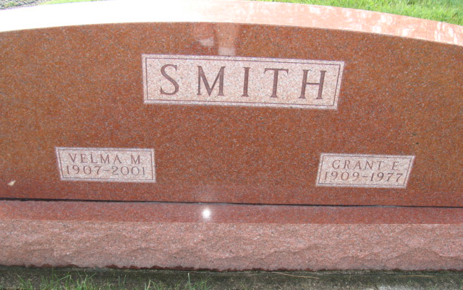
Photo by Alicia Kneuss

Velma M. Smith, 94, of Belleair Bluffs, Fla., a native of Berne, Ind., died Saturday, Aug. 4, 2001, in Largo. She was former co-owner of Grant's Fireside Furniture in Fort Wayne from 1964 to 1976. She was a member of the Church of the Isles in Indian Rocks Beach, a former choir member and was formerly of Fort Wayne.
Surviving are her daughters, Carolyn Schwartz of New Haven, Ind., Nancy Hansing of Hampstead, N.C., and Bette Burke of Belleair Beach; a sister, Faye Clauser of Berne, Ind.; and 11 grandchildren.
She was preceded in death by her husband, Grant, and a son, Richard G.
Graveside services are 10 a.m. Friday at MRE Cemetery, Berne, Ind. Calling is from 6 to 8 p.m. Thursday at Yager-Kirchhofer Funeral Home, Berne, Ind.
Memorials are to the Adams County Community Foundation or to fighting heart disease. Information provided by Yager-Kirchhofer Funeral Home, Berne, Ind., 1-219-589-3101.

News-Sentinel, The (Allen County, Indiana)
Tuesday, August 7, 2001

