Thomas J. Smith
July 29, 1830 – January 30, 1900

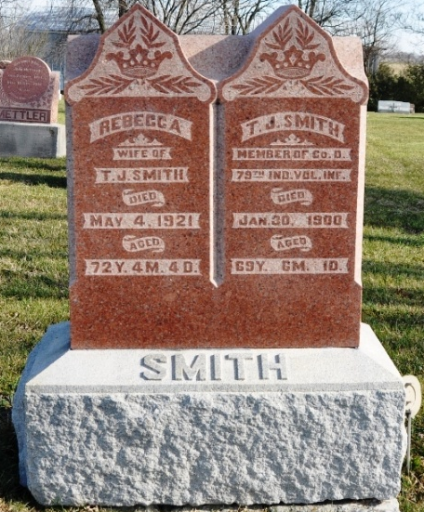
Photo by Deb Curry

Web: Indiana, U.S., Civil War Soldier Database Index, 1861-1865

Name Thomas J. Smith
Birth Year abt 1830
Age 32
Enrollment Date 8 Aug 1862
Discharge Date 7 Jun 1865
Place MT. Comfort, Indiana
Company D; Regiment 79
Notes Mustered Out.
**

Indiana, U.S., Marriage Certificates, 1960-2012

Name Thomas J Smith
Gender Male
Marriage License Date 19 Feb 1872
Marriage Date 7 Mar 1872
Marriage Place Adams, Indiana, USA
Spouse Rebecca Cook
Officiator Samuel Smith
**

Thomas J Smith from tree Duzan Family Tree by Stephen Duzan

Birth 29 Jul 1830 Kentucky, USA
Marriage 7 Mar 1880 Allen, Indiana, USA
Residence 1880 Adams, Indiana, USA
Death 30 Jan 1900 Allen, Indiana, USA
Father Thomas T Smith (Born 1798)
Mother Polly Duzan (1800-1829)
Spouse Rebecca Cook (1849-1921)
48021 People 10 Records 10 Sources

