Simon H. Smith
September 6, 1866 – February 16, 1943

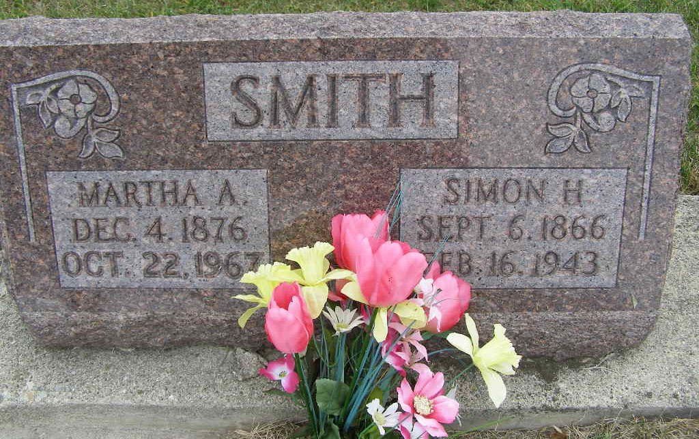
Photo by Shaunda Bedwell Opdycke

Indiana, U.S., Death Certificates, 1899-2017
Name Simon Smith
Gender Male
Race White
Marital Status Married
Age 76y 5m 10d
Birth Date 6 Sep 1866
Birth Place Adams County, Indiana
Death Date 16 Feb 1943
Death Place Rural, Adams, Indiana, USA
Death Registration Date 1943
Father John Smith b. Switzerland
Mother Barbara Gortner b. Switzerland
Spouse Martha Smith, age 66
Informant Mrs. Simon Smith
Burial M.R.E. Cem 2/19/1943

