Scott E. Smith
January 8, 1960 – February 15, 2020

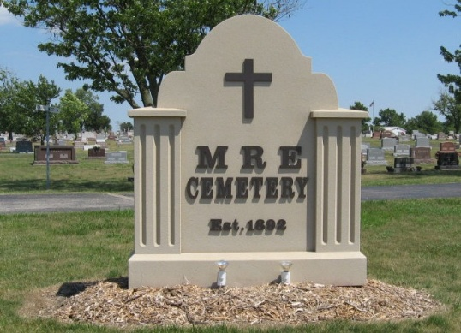
Photo by Tombstoner & Family

Scott E. Smith, 60, of Berne, IN, passed away at 9:45 PM on Saturday, February 15, 2020 at Lutheran Hospital in Fort Wayne, IN. He was born on Friday, January 08, 1960, in Adams County, IN. Scott was a 1978 graduate of South Adams High School. He worked as a manager at the Town of Geneva Waste Water. He enjoyed leather working and working on motorcycles.
He will be missed by his Forever Partner- Lynn Steen, Berne, IN, Mother - Judy (Ryf) Smith, Berne, IN, Son - Chad A. Smith, Step Daughter - Kimberly Hart Paxson, Eaton, IN, Brother – Mark A. (Mary) Smith, Berne, IN, Granddaughters - Lauren Elizabeth Paxson, Eaton, IN, Katherine Grace Paxson, Eaton, IN, and Several Nieces & Nephews. He was preceded in death by his Father - Leroy (Ike) Smith.
Family and friends may gather to share and remember at Downing & Glancy Funeral Home 100 N Washington Street Geneva on Wednesday, February 19, 2020 from 2:00 PM to 8:00 PM and from 10:00 AM to 12:00 PM, February 20, 2020. A service to celebrate his life will be at Downing & Glancy Funeral Home, 100 N Washington Street, Geneva at 12:00 PM on Thursday, February 20, 2020 with Pastor Roger Teeple officiating. Interment will follow in the M.R.E. Cemetery in Berne.
Preferred memorials may be made to the Adams County Humane Society or St. Jude's Hospital.

Downing & Glancy Funeral Home, Adams County, Indiana

