Samuel J. Smith
December 20, 1907 – August 2, 1979

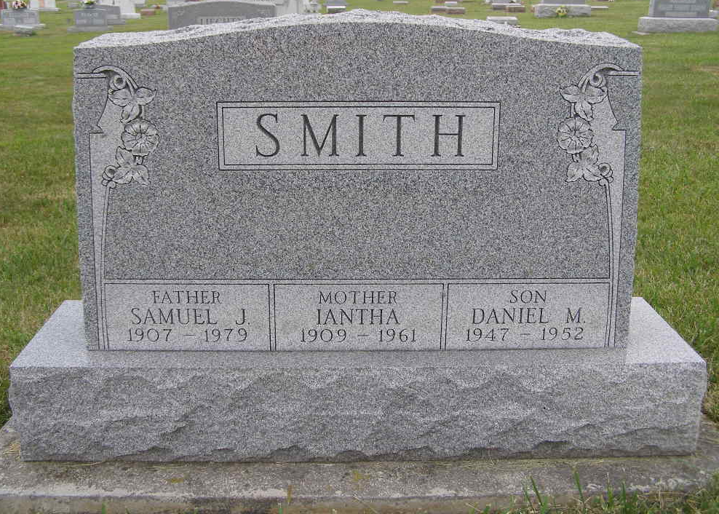
Photo by Shaunda Bedwell Opdycke

Indiana, U.S., Death Certificates, 1899-2017

Name Samuel J. Smith
Gender Male
Race White
Marital Status Widowed
Age 71
Birth Date 20 Dec 1907
Birth Place Indiana
Death Date 2 Aug 1979
Death Place Fort Wayne, Allen, Indiana, USA
Death Registration Date 1979
Father Simon Smith
Mother Martha Shank
Informant Mrs. Dennis Fuelling
Burial M.R.E. Cemetery 8/7/1979

