Ronald Lee Smith
March 1, 1947 – March 1, 1947
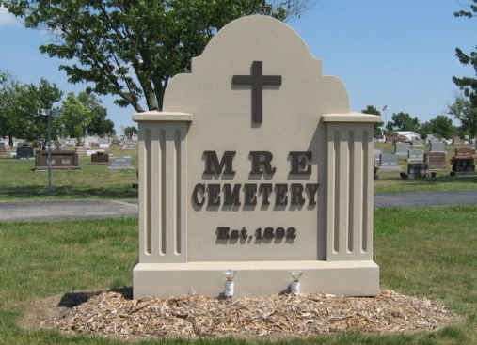
Photo by Tombstoner & Family

INFANT DIES

Ronald Lee Smith, infant son of Raymond and Albina Negri Smith of Berne, died at 11:50 o'clock Saturday forenoon at the Adams County Memorial Hospital. The child was born at 6:30 that morning and was premature. The parents and a sister, Brenda Marie, 1, survive. Graveside services were held Sunday at the MRE Cemetery, Rev. C P. Maas officiating.

Adams County, Indiana Historical Museum
1947Jan-May Scrapbook, image 107
Handwritten-Mon. March 3, 1947
**

Indiana, U.S., Death Certificates, 1899-2017

Name Ronald Lee Smith
Gender Male
Race White
Age 5 hours
Birth Date 1 Mar 1947
Birth Place Hospital Decatur, Indiana
Death Date 1 Mar 1947
Death Place Decatur, Adams, Indiana, USA
Death Registration Date 1947
Father: Raymond Smith
Mother: Albina Negri
Informant: Raymond Smith; Berne, Indiana
Burial: March 2, 1947; Cemetery; Berne, Indiana

