Rebecca (Cook) Smith
January 1, 1849 – May 4, 1921

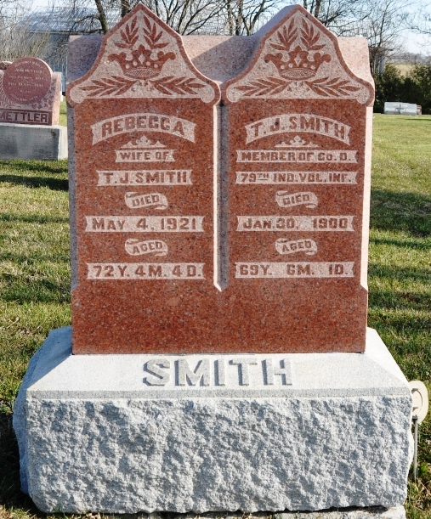
Photo by Deb Curry

Indiana, U.S., Death Certificates, 1899-2017

Name Rebecca Smith
[Rebecca Cook]
Gender Female
Race White
Marital Status Widowed
Age 72y 4m 4d
Birth Date 1 Jan 1849
Birth Place Indiana
Death Date 4 May 1921
Death Place Wabash, Adams, Indiana, USA
Death Registration Date 1921
Father John Cook
Mother Lydia Baker
Informant Mrs. Eve Lanning, Berne, IN
Burial M.R.E. 5-6-1921

