Otto Christian Smith
September 24, 1894 – August 28, 1927

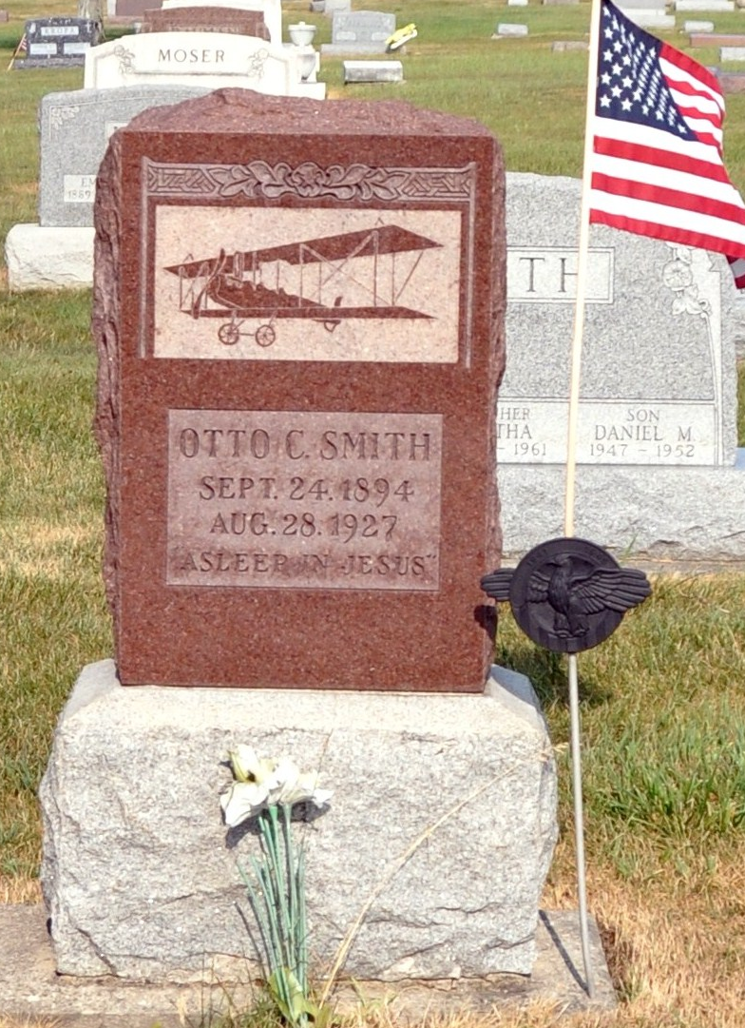
Photo by Deb Curry

STUNT FLIER DIES WHEN PLANE FALLS

[Special to The Indianapolis Star]
Bluffton, Ind., Aug. 28 – Otto Smith, 25 years old, was fatally injured when an airplane in which he was exhibiting stunts at an aerial circus crashed to earth at Montpelier, near here, at 4 o’clock this afternoon. He died in the office of Dr. Shaddy, Montpelier physician, a few moments after the accident.
The plane was only twenty feet above the flying field when it swung into a nose dive and crashed to earth. Bystanders took the crushed body from the wreckage only a second before the plane burst into flames.
Mr. Smith conducted a flying school at Linn Grove, near here, and had been flying for some time.

Indianapolis Star, Marion County, Indiana
Monday, August 29, 1927
**

Indiana, U.S., Death Certificates, 1899-2017

Name Otto Christian Smith
Gender Male
Race White
Marital Status Married
Age 32y 11m 3 d
Birth Date 25 Oct 1894
Birth Place Adams County, Indiana
Death Date 28 Aug 1927
Death Place Montpelier, Blackford, Indiana, USA
Death Registration Date 1926-1927
Father Simon Smith
Mother Martha Shank
Spouse Estella Hern Smith
Informant Mrs. Otto Smith
Burial Berne, Indiana 8/31/1927

