Orva Nelson Smith
December 24, 1890 – October 24, 1961

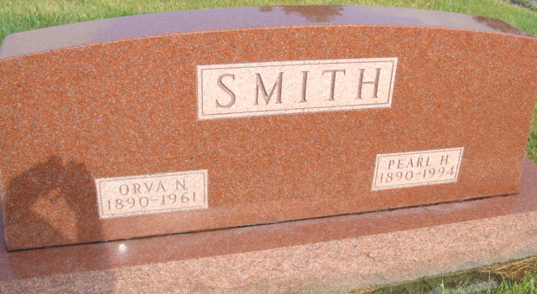
Photo by Alicia Kneuss

Indiana, U.S., Death Certificates, 1899-2017
Name Orva Nelson Smith
Gender Male
Race Caucasian (White)
Marital Status Married
Age 70
Birth Date 24 Dec 1890
Birth Place Indiana
Death Date 24 Oct 1961
Death Place Marion, Grant, Indiana, USA
Death Registration Date 1961
Father Martin Smith
Mother --- Kern Smith
Informant Grant Smith, son
Burial 10/26/1961 MRE Cemetery
**

Indiana, U.S., Marriages, 1810-2001
Name Orva N Smith
Gender Male
Race White
Age 18
Event Type Marriage Registration (Marriage)
Birth Date 24 Dec 1890
Birth Place Adams, Indiana
Marriage Date 1 Sep 1909
Marriage Place Indiana, United States
Residence Place Adams, Indiana
Father Martin L Smith
Mother Druscilla Kern
Spouse Pearl Heeler Or Heller
Page 44

