Nancy J. (Sprunger) Smith
March 13, 1951 – January 2, 2014
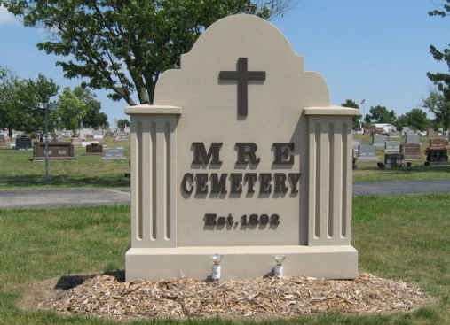
Photo by Tombstoner & Family

Nancy J. Smith, 62, Berne, passed away Thursday, January 2, 2014 unexpectedly at her home. She was born to Merlin W. and Berniece Nussbaum Sprunger on March 13, 1951 in Adams County.
She was a member of the First Mennonite Church. Nancy was a former employee of Rustic Hutch in Ft. Wayne and later the Berne Dollar General Store. She enjoyed reading for a pastime.
Survivors include sons: Jeremy (Nicole) Smith of Ft. Wayne, Justin (Jennifer) Smith of Ft. Wayne, brother, Ryan Sprunger of Berne, sister: Charlotte (Fred) Linn of Berne, Sharon (Tom) Ninde of Geneva, and 4 grandchildren.
Memorial services are Saturday, January 4 at 2:00 pm with visitation from 12:30 pm to time of services at the First Mennonite Church Chapel. Officiating is Pastor Jerry Flueckiger. Burial is in the MRE Cemetery, Berne.
Preferred memorials are to the First Mennonite Church Library and/or the Children's Ministry.

Yager-Kirchhofer Funeral Home, Adams County, Indiana
January 2, 2014

