Maurice Maxwell Smith
September 20, 1914 – February 1, 1983

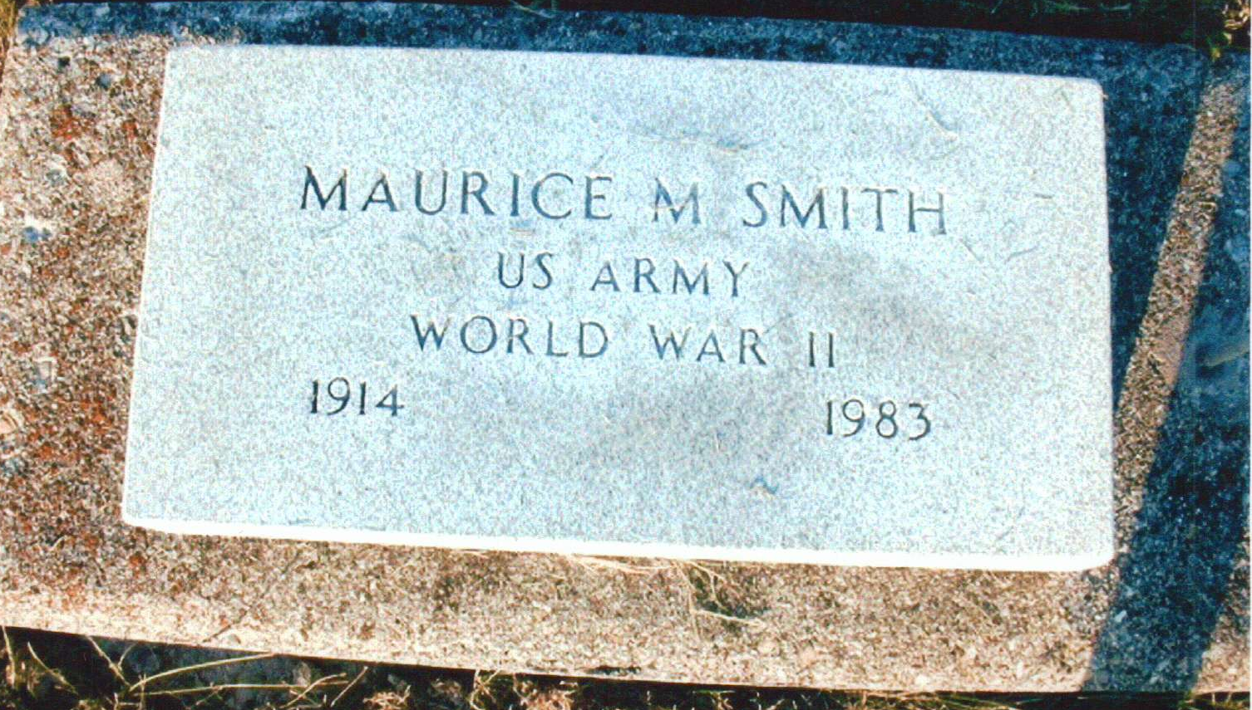
Photo by JC

Indiana, U.S., Death Certificates, 1899-2017
Name Maurice M. Smith
Gender Male
Race White
Marital Status Never Married (Single)
Age 68
Birth Date 20 Sep 1914
Birth Place Indiana
Death Date 1 Feb 1983
Death Place Berne, Adams, Indiana, USA
Death Registration Date 1983
Father A. Clayton Smith
Mother Emma Bixler
Informant Corinne Miller, Berne, IN
Burial M.R.E. 2/3/1983

