Martin L. Smith
November 6, 1859 - 1950

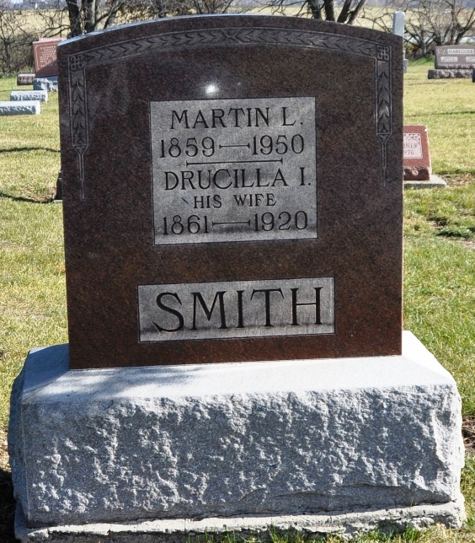
Photo by Shaunda Bedwell Opdycke

Indiana, U.S., Death Certificates, 1899-2017

Name Martin L Smith
Gender Male
Race White
Marital Status Married
Age 90
Birth Date 6 Nov 1859
Birth Place Adams County
Death Date 26 Apr 1950
Death Place Berne, Adams, Indiana, USA
Death Registration Date 1950
Father Franklin Smith
Mother Catherine Rawley
Informant O. N. Smith, Berne, IN
Burial 4-28-1950 M. R. E. Cemetery
**

MARTIN L. SMITH.

Martin L. Smith, who resides on a well improved farm in Wabash township, Adams county, Indiana, is a native of the locality in which he now lives and was born November 6, 1859. He is a son of Franklin and Catherine (Rawley) Smith, residents, respectively, of Pennsyl-vania and Virginia, who came to Indiana in an early day, and such was the roughness of the country at that time that it was necessary for them to cut a road through the woods. To them were born nine children: Elizabeth, deceased; William R.; John, deceased; one who died in infancy; Sidney, deceased; Martin, the subject; Eliza J.; Alice, deceased, and Hannah. After the father of these children married they moved to Root township, where he remained a short time, eventually going elsewhere, but before his death returned to Root township and died there in 1871. His wife is still living in Decatur. After her first husband's death she became the wife of J. Rugg, of Decatur, now deceased.
The subject of this sketch received a good practical education in the common schools and early took up the pursuit of farming under the able tutorship of his father. He has been eminently successful as an agriculturist, due to the sound judgment exercised by him in the rotation of his crops and other features which contribute to successful agriculture. He owns one hundred and nine acres of land, on which he has resided since 1887, and to which he has devoted his entire time. He carries on general farming and gives some attention to the breeding and raising of Poland China hogs and Shropshire sheep. Mr. Smith has erected all of the present buildings on the farm and has also constructed the splendid fences and well built ditches which now characterize the place. In politics he is a Democrat and has served two terms on the advisory board of the township. He is a member of the Evangelical church.
In 1881 he married Miss Isabella Kern, daughter of Philip B. and Mary (Luckey) Kern, early settlers of Union township. To this union were born six children, namely: Philip, Hannah, Clayton, Orvie, Gertrude and Leslie, all at home.

Snow's History of Adams County, Indiana, John Fletcher Snow, B. F. Bowen, Indianapolis, IN, 1907, p. 403 (image 825)

