Lewis M. Smith
October 28, 1926 – August 1, 2004

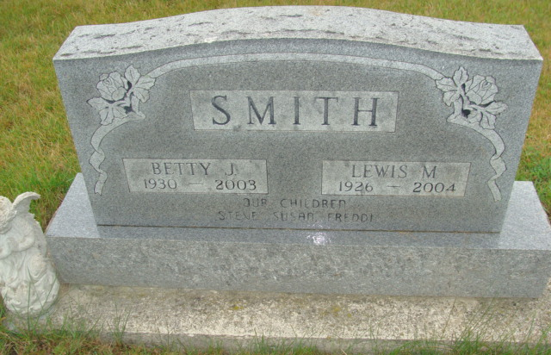
Photo by Alicia Kneuss

Lewis M. Smith, a union carpenter with Local #332, died at 5:25 p.m. Sunday, Aug. 1 at Chalet Village in Berne. He was a veteran of World War II and the Korean War, serving with the U.S. Navy and the U.S. Marines and receiving the Purple Heart. He was a member of Berne American Legion Post 468 and Geneva VFW.
Born Oct. 28, 1926 in Marion to Archie and Gladys Dague Smith, his marriage on April 12, 1946 in Monroe was to Betty Christener, who preceded him in death in 2003.
Funeral services will take place at 10:30 a.m. Wednesday at Yager-Kirchhofer Funeral Home in Berne with Rev. Keith Rupp officiating and burial in M.R.E. Cemetery. Calling at the funeral home will be today from 2 to 5 and 6 to 8 p.m. and Wednesday for one hour prior to services. Military rites will be conducted at the cemetery by Berne Post 468. Preferred memorials are to West Missionary Church.

Bluffton News Banner, Wells County, Indiana
August 3, 2004

