Leslie B. Smith
January 12, 1899 – January 24, 1969

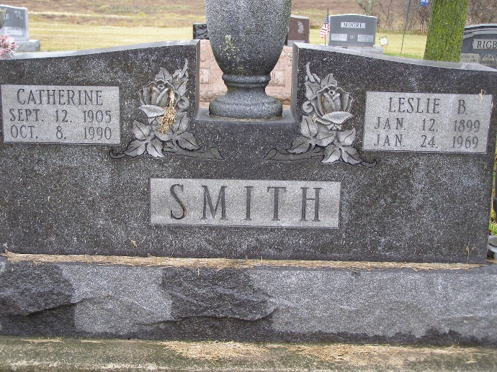
Photo by Shaunda Bedwell Opdycke

L. B. Smith, 70, Dies Today at Sarasota, Fla.
Local Retired Furniture Salesman Succumbs to Pneumonia

Leslie B. Smith, 70, prominently known Berne man and a furniture salesman for many years, died early this morning in Sarasota Memorial Hospital, Sarasota, Florida. He entered the hospital 2 weeks ago after a siege of the flu turned into pneumonia. Mr. Smith had been afflicted with a heart ailment for some time, and a combination of pneumonia and heart disease caused his death. He had been in oxygen several days.
Mr. and Mrs. Smith spent their winters in Florida and had gone to Sarasota a few weeks ago. In Berne, they resided at 265 Dearborn St. They had a cottage at Lake Wawasee, where they spent some of the summer months.
Mr. Smith had retired some time ago as a furniture salesman. He began his career as a salesman for Dunbar furniture, then he and his brother, O. N. Smith founded Smith Brothers Furniture Manufac-turing Company, of which he was part owner for many years. He was a salesman for Smith Brothers until his retirement.
He was born here January 12, 1899, a son of Martin L. and Mabel Kern Smith. He graduated from Berne high school and attended Washington and Lee University in Washington, D. C. He was married to Kate Anderson of Geneva, who survives.
Mr. Smith was a member of the Trinity United Methodist Church, Geneva Lodge 621, of the F&AM, Scottish Rite of Fort Wayne, the Mizpah Temple, Fort Wayne, and the Elks Lodge 993 of Decatur.
Surviving are the wife; a son, John Smith, Findlay, Ohio, who is one of the owners of Riesen and Smith Motors, Inc. of this city; a daughter, Mrs. Carl (Marilyn) Muselman, Berne; 7 grandchildren; a brother, A. C. Smith, Berne 2 sisters, Mrs. Elmer Stucky, Syracuse and Mrs. Noah Bixler, Decatur.

Date of Burial: January 27, 1969
Burial: MRE – Lot 3, Sect. 8, 4th Addition

Berne (IN) Public Library Heritage Room
1968-1971 MRE Obit Scrapbook

