Leroy Sheldon Smith
October 26, 1937 – November 14, 2018
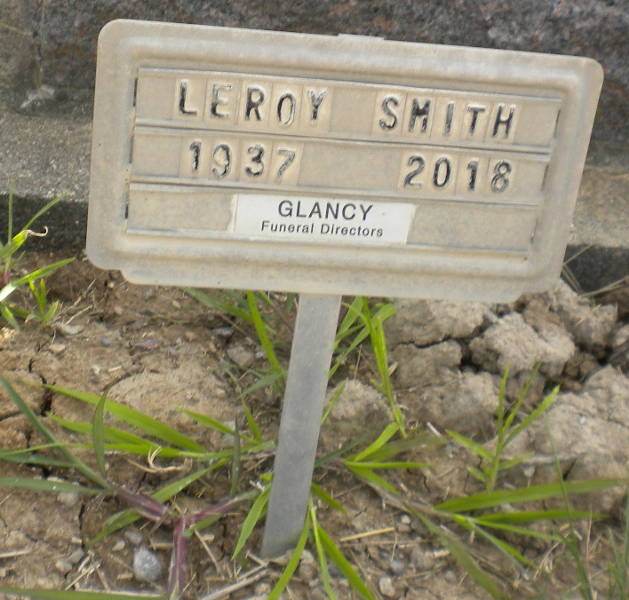
Photo by DSON1492

Leroy S. Smith, 81, of Berne, IN, passed away at 5:47 PM on Wednesday, November 14, 2018 at Adams Memorial Hospital in Decatur, IN. He was born on Tuesday, October 26, 1937, in Muncie, IN. He married Judy (Ryf) Smith on Sunday, March 25, 1956 at the Cross Reform Lutheran Church, Berne, IN.
Ike attended Jefferson School in Jefferson Twp. He owned and operated Smith Cycle for 30 years and then retired from Macitosh in Berne, IN. He was a 25 year member of the Geneva Masonic Lodge. Ike enjoyed collecting guns & knives, and sitting on his swing watching his kids come and go. He and Judy had spent the last 13 years wintering in Florida.
Ike will be sadly missed by his Wife - Judy (Ryf) Smith, Berne, IN, Sons - Mark (Mary) Smith, Berne, IN, Scott (Lynn) Smith, Berne, IN, Brothers - Rollin "Mike" (Janice) Smith, Geneva, IN, Mack (Dianna) Smith, Bryant, IN, Sister - Brenda Smith, Berne, IN, Half Sister - Bonnie Wilson, Hartford City, IN, 5 Grandchildren, and 9 Great Grandchildren.
He was preceded in death by his Father - Roy Smith, and Mother - Madge (Gibson) Smith.
Family and friends may gather to share and remember at Downing & Glancy Funeral Home 100 N Washington Street Geneva on Saturday, November 17, 2018 from 11:00 AM to 2:00 PM. A service to celebrate his life will be at Downing & Glancy Funeral Home at 2:30 PM on Saturday, November 17, 2018 with Don Gerber officiating. Interment will follow in the M.R.E. Cemetery in Berne.

Unknown source

