Lucinda Pearl (Heller) Smith
December 26, 1890 – September 12, 1994

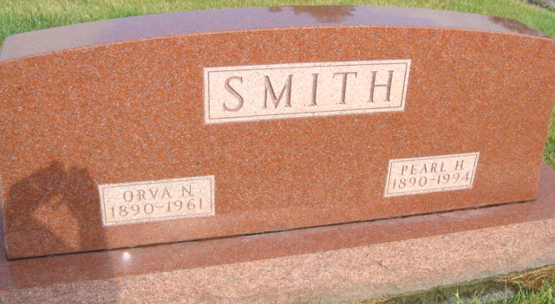
Photo by Alicia Kneuss

L. PEARL SMITH, 103, of Berne died yesterday in Swiss Village. The Adams County native was the widow of Orva N., who died in 1961.
Surviving is a daughter-in-law, Velma Smith of Bellaire Bluffs, Fla.
Services are 10:30 a.m. Thursday in Yager-Kirchhofer Funeral Home, Berne, where calling is 3 to 8 p.m. tomorrow and 8 to 10:30 a.m. Thursday. Burial will be in MRE Cemetery. Preferred memorials are gifts to Swiss Village or Trinity United Methodist Church, both in Berne.

News-Sentinel, The (Allen County, Indiana)
Tuesday, September 13, 1994
**

Indiana, U.S., Death Certificates, 1899-2017
Name L Pearl Smith
[L Pearl Heller]
Gender Female
Race White
Marital Status Widowed
Age 103
Birth Date 16 Dec 1890
Birth Place Adams County
Death Date 12 Sep 1994
Death Place Berne, Adams, Indiana, USA
Death Registration Date 1994
Father Edwin Heller
Mother Sarah Miller
Informant Carolyn Schwartz, granddaughter
Burial M.R.E. 9/15/1994

