Leah Marie (Allspaw) Smith
January 31, 1897 – November 21, 1981

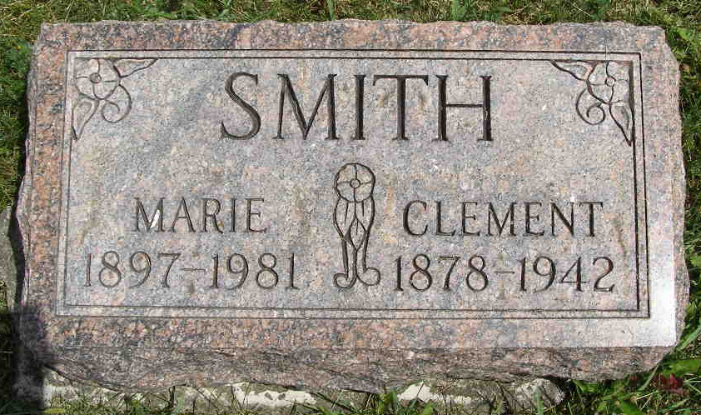
Photo by Shaunda Bedwell Opdycke
Indiana, U.S., Marriages, 1810-2001

Name L Marie Allspaw
Gender Female
Race White
Age 27
Event Type Marriage Registration (Marriage)
Birth Date 31 Jan 1897
Birth Place Willshire, Ohio
Marriage Date 28 Jun 1924
Marriage Place Indiana, United States
Residence Place Berne, Adams, Indiana
Father D W Allspaw
Mother Emma Seitz
Spouse Clem N Smith
Page 253
FHL Film Number 002321631
**

Florida, U.S., Death Index, 1877-1998

Name Leah Marie Smith
Race White
Age at Death 84
Birth Date 31 Jan 1897
Death Date 21 Nov 1981
Death Place Broward, Florida, United States

