Martha A. (Shank) Smith-Kindell
December 12, 1876 – October 22, 1967

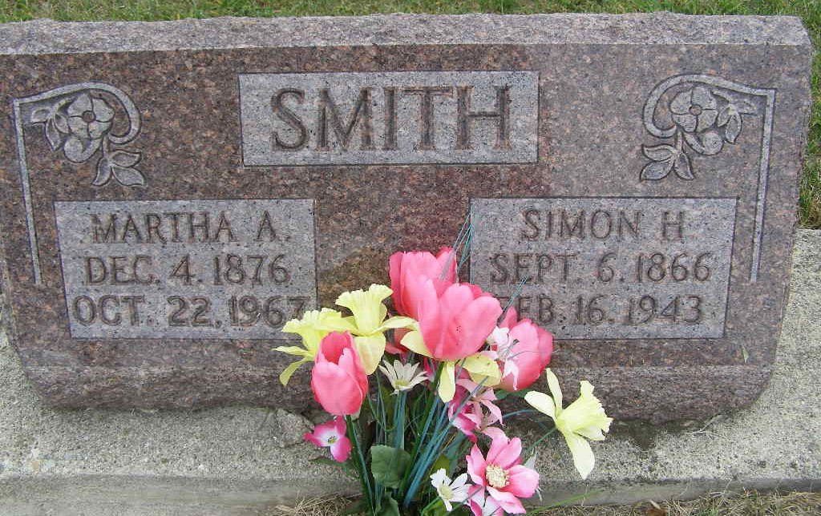
Photo by Shaunda Bedwell Opdycke

Mrs. Martha Smith Kindell, 90, a native of Adams County and resident of Monroe for the past 15 years, died at 2:55 am Sunday at the Glenacres Nursing Home in Fort Wayne, where she had been a patient two months. She was born in French Township December 12, 1876, a daughter of Frederick and Mary Grim Shank. Her first husband, Simon Smith died in 1943 and her second husband, William Kindell, is also deceased. Mrs. Kindell was a member of the Monroe Methodist Church.
Surviving are five daughters, Mrs. P. W. (Emma) Barker, Mrs. Lee (Florence) Garrison, and Mrs. Walter Sprunger, all of Fort Wayne, Mrs. Tony (Luther) Arthur of Albion and Mrs. William Beirne of Kendall Park, N.J.; three sons, Carl Smith of Warsaw, Samuel Smith of LaGrange and Joseph Smith of Tucson, Ariz.; 44 grandchildren; 78 great grandchildren, and 20 great-great grandchildren. Three sons and one daughter are deceased.
Funeral services were conducted at 2:30 pm today at the Monroe Methodist Church, with Rev. Charles Elam and Rev. Willis Gierhart officiating. Burial was in MRE Cemetery west of Berne.
**

Rites today for Martha S Kindell

Services for Mrs. Martha Kindell, 90, will be at 2:30 pm Wednesday at Monroe Methodist Church, the Revs. Charles Elam and Willis Gierhart officiating. Mrs. Kindell died at 2:55 am Sunday at Glenacres Convalescent Home. She was a member of Monroe Methodist Church.
Surviving include five daughters, Mrs. P. W. Barker, Mrs. Lee J. Garrison, and Mrs. Walter Sprunger, all of Fort Wayne, Mrs. Tony Arthur of Albion and Mrs. William Beirne of Kendall Park, N.J.; three sons, Carl Smith of Warsaw, Samuel Smith of LaGrange and Joseph Smith of Tucson, Ariz.; 44 grandchildren; 78 great-grandchildren, and 20 great-great grandchildren.
Burial will be in MRE Cemetery, Berne. Friends may call at Elzey Home for Funerals, Waynedale, until 11 am Wednesday when the body will be taken to the church.

Date of Death: October 23, 1967 Date of Burial: October 25, 1967 Burial: Lot 325, Orig. Platt

Berne (IN) Library Heritage Room
MRE Obit Book 1966 – 1972, image 93 & 94

