Judy D. (Ryf) Smith
March 20, 1937 – March 14, 2021
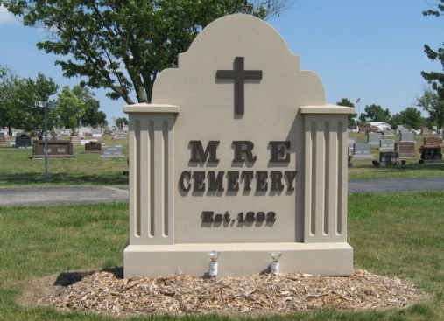
Photo by Tombstoner & Family

Judy D. Smith, 83, of Berne, IN, passed away at 11:12 PM on Sunday, March 14, 2021 at her home in Berne, IN.
She was born on Saturday, March 20, 1937, in Decatur, IN. She married Leroy "Ike" S. Smith on Sunday, March 25, 1956 in Cross Reform Lutheran Church; he precedes her in death on November 14, 2018.
Judy was a graduate of Berne High School and also received her beautician license from Ft. Wayne Beauty College. She was a beautician for many years and had worked as manager at the Checker gas station and had retired from Micro Matic.
Before Ike's passing in 2018 he and Judy wintered in Florida for several years. She was a member and president of a CB club where she was known as Candy. Judy enjoyed crocheting, knitting, stitching blankets, and loved putting photo albums together.
She will be sadly missed by her Son - Mark (Mary) Smith, Berne, IN, Brother - Jack Ryf, FL., Sister - Jylain Amstutz, Berne, IN, Sister - Kay Gerber, Ft. Wayne, IN, 4 Grandchildren, and 11 Great Grandchildren.
She was preceded in death by her Father - Herman Ryf, Mother - Agnes (Garlinger) Ryf, Husband - Leroy "Ike" S. Smith, and Son - Scott Smith.
​ Family and friends may gather to share and remember at Downing & Glancy Funeral Home 100 N Washington Street Geneva on Wednesday, March 17, 2021 from 12:00 PM to 3:00 PM. A graveside service to celebrate her life will be at M.R.E. Cemetery, Berne at 3:30 PM on Wednesday, March 17, 2021. Interment will follow in the M.R.E. Cemetery in Berne.
Preferred memorials: St. Jude Children's Research Hospital, 501 St. Jude Place, Memphis, TN 38105-1942
.
Glancy Funeral Homes, Adams County, Indiana
March 15, 2021
**

Judy D. Smith, 83, of Berne passed away Sunday, March 14, 2021, at 11:12 p.m. at her home. She was born Saturday, March 20, 1937, in Decatur to Herman and Agnes (Garlinger) Ryf. She was married Sunday, March 25, 1956, at Cross Reform Lutheran Church to Leroy “Ike” S. Smith.
She was a graduate of Berne High School and also received her beautician license from Ft. Wayne Beauty College. She was a beautician for many years, had worked as manager at the Checker gas station and retired from Micromatic. Before her husband’s passing in 2018, they wintered in Florida for several years. She was a member and president of a CB club, where she was known as Candy. She enjoyed crocheting, knitting, stitching blankets and loved putting photo albums together.
She is survived by her son, Mark (Mary) Smith of Berne; brother, Jack Ryf of Florida; two sisters, Jylain Amstutz of Berne; and Kay Gerber of Fort Wayne; four grandchildren; and 11 great-grandchildren.
She was preceded in death by her parents; her husband on November 14, 2018; and son, Scott Smith.
Visitation will be Wednesday, March 17 from 12-3 p.m. at Downing & Glancy Funeral Home, 100 N. Washington St., Geneva followed by a graveside service at 3:30 p.m. at MRE Cemetery in Berne.
Memorials may be made St. Jude Children's Research Hospital, 501 St. Jude Place, Memphis, TN 38105-1942. Arrangements provided by Downing & Glancy Funeral Home in Geneva.

The Berne Witness, Adams County, Indiana
March 17, 2021

