John Leslie Smith
July 22, 1929 – May 8, 2007
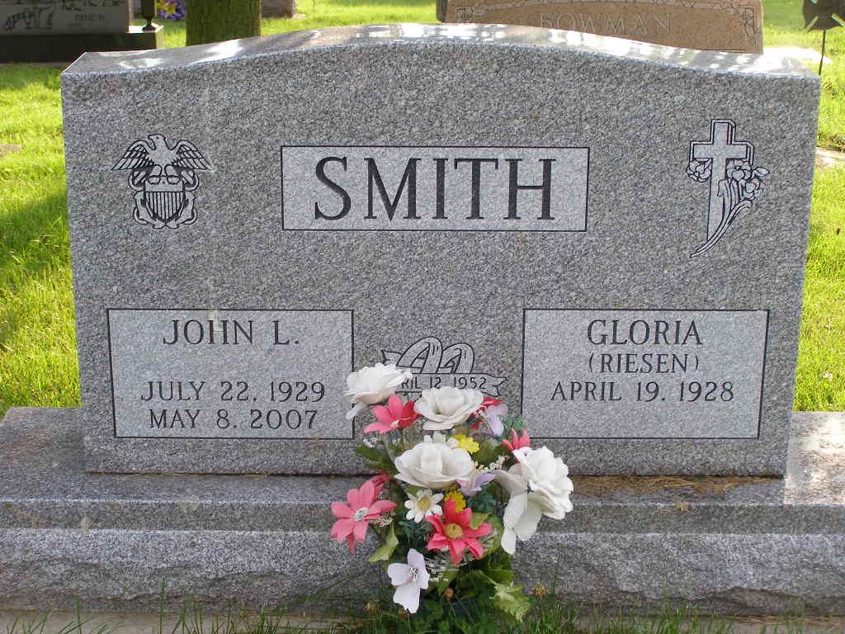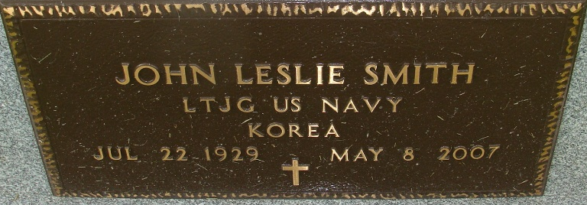
Photo by Shaunda Bedwell Opdycke & Alicia Kneuss

John L. Smith, 77 years old of Evansville, Indiana, passed away at 4:45 p.m. Tuesday, May 8, 2007. He was a native of Berne, Indiana. John was born on July 22, 1929 in Adams County, Indiana, the son of the late Leslie Smith and the late Catherine (Anderson) Smith. He married Gloria Riesen on April 12, 1952 in Berne, Indiana and she survives.
John was a member of the Crossroads Christian Church in Evansville, Indiana. John was a veteran of the United States Navy, where he served as a naval aviator, tracking Russian submarines during the Cold War. He served as president of Smith Brothers Furniture of Berne, Indiana; Swiss City Furniture of Berne, Indiana; and was president of M.D.C.-Midwest, Inc.
Surviving are his wife, Gloria Smith of Evansville, Indiana; son, John Lee (Ann) Smith of Evansville, Indiana; son, Les (Cindy) Smith, of Athem, Arizona; daughter, Lana (Rick) McCleary of Atlanta, Georgia; daughter, Laurel (Larry) Oscar of Atlanta, Georgia; sister, Marilyn Muselman of Berne, Indiana; and ten grandchildren: Matthew, Joshua, Jeremy, Kristen, Jennifer McCleary; Jay, Sara, Katie, Andrea, and Elizabeth Smith. John was preceded in death by one son, Lynn J. Smith.
Funeral services will be held at 10:30 a.m. Saturday, May 12, 2007 in the First Missionary Church, Berne, Indiana with Rev. Max Haines and Pastor Jack Arney officiating. Interment will follow in the M.R.E. Cemetery in rural Berne, Indiana. Friends will be received from 4:00 - 8:00 p.m. Friday, May 11, 2007 in the Yager Kirchhofer Funeral Home, Berne, Indiana and one hour prior to the service at the church on Saturday.
Preferred memorials are to Navigators or the Crossroads Christian Church in Evansville, Indiana.

Yager-Kirchhofer Funeral Home, Adams County, Indiana

