Jerry Lee Smith
January 13, 1939 – September 3, 2013
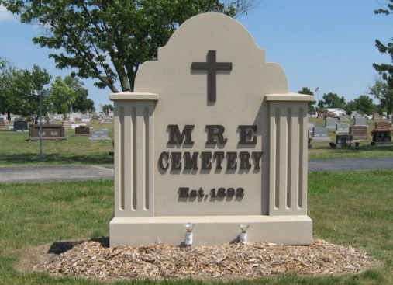
Photo by Tombstoner & Family

Jerry L. Smith, 74, Berne, died Tuesday at Swiss Village in
Berne. Survivors include his wife, Janet; daughter, Kim (Mike)
Minneci of Cary, Ill.; brother, Robert Smith of Richmond;
sisters, Gloria Armstrong of Dayton and Carolyn Race of New
Paris, Ohio. Visitation will be from 10 to 1 p.m. on Thursday with
funeral services to follow at Yager-Kirchhofer Funeral Home.
Burial will be in MRE Cemetery, Berne.
Decatur Daily Democrat, Adams County, Indiana
September 4, 2013
**

Jerry L. Smith, 74, Berne, passed away Tuesday, September 3, 2013 at Swiss Village, Berne. He was born to John and Pearl (Jennings) Smith on January 13, 1939 in Richmond, Indiana. He married Janet Rumery on October 6, 1962. He was of the Lutheran faith and worked in Berne at Dunbar Furniture and later retired from Smith Bros of Berne as a fabric cutter with 32 years of service. He was a veteran serving in the U.S. Navy during the Bay of Pigs. Special interests include being an avid sports fan rooting for the I.U. Hoosiers. And was fond of his family. Survivors include his wife, Janet, daughter, Kim(Mike)Minneci of Cary, Ill., brother, Robert Smith of Richmond, sisters, Gloria Armstrong of Dayton, OH, and Carolyn Race of New Paris, OH., and 2 grandchildren. Preceding in death is his daughter, Kev Smith Cook. and his parents. Funeral services are on Thursday, September 5 at 1 PM at the Yager-Kirchhofer Funeral Home with visitation from 10 am to 1 PM. Officiating is Pastor Kris Kruchkow. Burial is in the MRE Cemetery, Berne with military rites by the Berne American Legion Post #468. Preferred memorials are to the Family &/or the Adams County Veteran Memorial Project.

Yager-Kirchhofer Funeral Home, Adams County, Indiana
**

Indiana, U.S., Death Certificates, 1899-2017

Name Jerry L Smith
Gender Male
Race White
Age 74
Birth Date 13 Jan 1939
Birth Place Orion, Indiana
Death Date 3 Sep 2013
Death Place Berne, Adams, Indiana, USA
Death Registration Date 2013
Father John Smith
Mother Pearl Jennings
Spouse Janet Smith, informant
Burial MRE Cemetery
Certificate Number 042257

