Jennie A. (Tinkham) Smith
August 8, 1890 – June 30, 1951

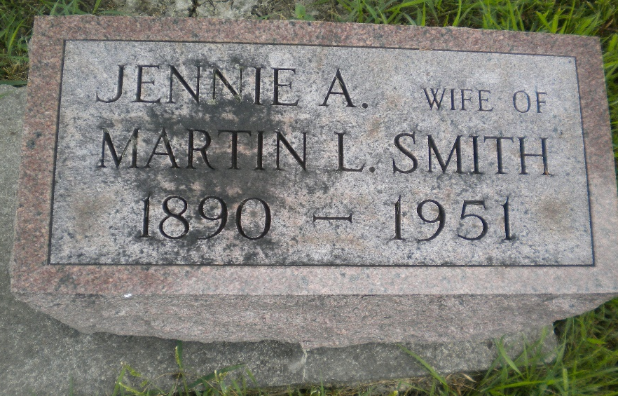
Photo by DSON1492

Indiana, U.S., Death Certificates, 1899-2017

Name Jennie Smith
[Jennie Tinkham]
Gender Female
Race White
Marital Status Widowed
Age 60
Birth Date 8 Aug 1890
Birth Place Blue Creek Twp, Adams Co, Indiana
Death Date 30 Jun 1951
Death Place Decatur, Adams, Indiana, USA
Death Registration Date 1951
Father Frank M Tinkham
Mother Anna Waggoner
Informant Marion L. Smith
Burial 7/2/1951 M.R.E. Cemetery

