Janet K. (Rumery) Smith
June 22, 1942 – August 12, 2022
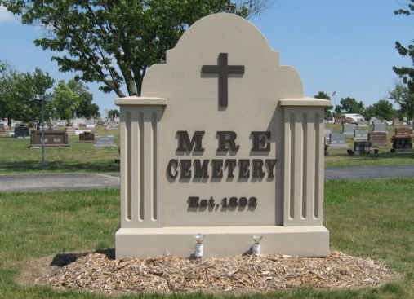
Photo by Tombstoner & Family

Janet K. Smith, 80, a former longtime resident of Berne, passed away Friday, August 12, 2022, at Alden Poplar Creek in Hoffman Estates, Illinois. She was born June 22, 1942, in Bellefontaine, Ohio to Roger and Mary (Browning) Rumery. She was married for 50 years to Jerry L. Smith.
She was a devoted wife, mother and grandmother who enjoyed time spent with family. She had been employed at Nussbaum Novelty and later retired from Franklin Electric.
She is survived by her daughter, Kimberly (Michael) Minneci; two grandchildren, Emily and Ben; and several nieces and nephews.
She was preceded in death by her parents; her husband in 2013; daughter, Kev Cook; three brothers, Charles Rumery; Robert Rumery; and Bruce Rumery; and two sisters, Eleanor Knepp; and Judy Rollins.
A graveside service for family at MRE Cemetery is being planned for a future date.

The Berne Witness, Adams County, Indiana
August 17, 2022

