Iantha (Tyler) Smith
March 19, 1909 – July 25, 1961

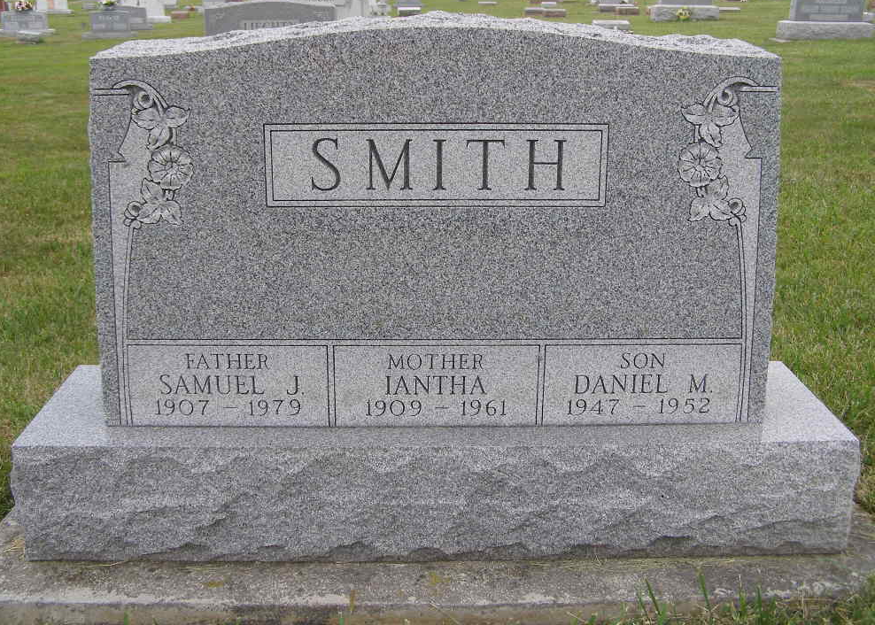
Photo by Shaunda Bedwell Opdycke

MRS. SMITH BURIED HERE THIS AFTERNOON
LAGRANGE WOMAN, 52, DIES IN HOSPITAL LATE TUESDAY
Mrs. Iantha Smith, 52, of R. R. 3, LaGrange, was buried this afternoon in the M.R.E. Cemetery of Berne following funeral services at 1 p.m. at the Weicht Funeral Home in Angola. Mrs. Smith died Tuesday evening in Elmhurst Hospital, Angola, where she had been a patient eight days.
The Smith family formerly resided in this community and in 1952 a son of Mr. and Mrs. Smith was buried in the local cemetery. Mrs. Smith was the daughter of William and Mary Turner Tyler. The parents survive.
Also surviving are the husband, Samuel; five sons, Lowell, Frankfort; Ronald, Madison, Maine; John Allen and James W., who are in Germany with the military forces and who came home for the funeral; and Maurice, of Stroh; a daughter, Sharon, at home; a brother, George Tyler, Muncie and three sisters, Mrs. Clifford Yager, Muncie; Mrs. Everett Barber, Albany and Mrs. Ray Munyan, Kendallville.
Adams County, Indiana Historical Museum
1951Jan-Aug1962 Scrapbook; image 28
Handwritten-Fri. July 28, 1961
**

MRS. IANTHA SMITH

Mrs. Iantha Smith, 52, R.R. 3, LaGrange, died last Tuesday evening in Elmhurst hospital. The husband, Samuel; five sons, one daughter, one brother, three sisters and the parents survive. Services were held at 1 p.m. Friday in the Weicht Funeral Home, followed by burial in MRE cemetery, Berne.

Angola Herald, Steuben County, Indiana
Wednesday, August 2, 1961
**

Indiana, U.S., Death Certificates, 1899-2011
Name: Iantha Smith
[Iantha Tyler]
Gender: Female
Race: White
Age: 52
Marital status: Married
Birth Date: 19 Mar 1909
Birth Place: Indiana
Death Date: 25 Jul 1961
Death Place: Angola, Steuben, Indiana, USA
Father: Willis Tyler
Mother: Mary Turner
Informant: Samuel Smith; husband; LaGrange, Indiana
Burial: July 28, 1961; MRE Cemetery; Berne, Indiana

