Harry Vernon Smith
March 6, 1934 – July 15, 2002

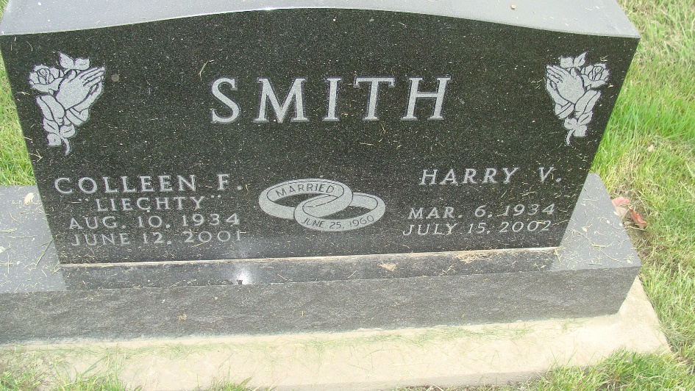
Photo by Alicia Kneuss

Harry V. Smith, 68, died at 4:45 p.m. Monday, July 15, at his residence at 880 Chalet Dr. in Berne. Mr. Smith was employed at International Harvester at Fort Wayne. He was a member of the First Missionary Church at Berne.
He was born in Adams County March 6, 1934 to Godfred W. and Opal L. McFarren Smith. His marriage on June 25, 1960 was to Colleen F. Liechty, who died June 12, 2001.
Surviving are a son, Matthew of Fort Wayne; three daughters, Lori Simpson and Mrs. Adam (Amy Jo) Bertsch, both of Berne, and Mrs. Bradley (Debra) Gerber of Decatur; nine grandchildren; and one great-grandchild. A brother and three sisters are deceased.
Services at 10 a.m. Friday will be at the First Missionary Church in Berne with Rev. Howard Nussbaum and Rev. Gareth Wiederkehr officiating. Burial will be in the MRE Cemetery at Berne. Visitation hours at Haggard & Sefton Funeral Home in Decatur will be Thursday from 2 to 4 and 6 to 8 p.m. and at the church Friday for one hour prior to services. Memorials to the church or to the family.

Bluffton News-Banner, Wells County, Indiana
Unknown date

