Harley B. Smith
July 21, 1883 – March 14, 1961
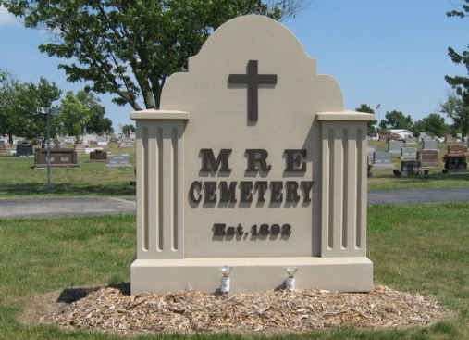
Photo by Tombstoner & Family

HARLEY B. SMITH IS TAKEN BY DEATH

Harley B. Smith, 77, of Fort Wayne, a native of Adams County, died Tuesday at the St. Joseph hospital. Mr. Smith, retired, formerly operated a hammermill at Berne. He was born in Adams County July 21, 1883, a son of Barkley and Amanda Stacy-Smith.
Surviving are one son, Lawrence S. Smith of Decatur; four daugh-ters, Mrs. Kenneth (Virginia) Houser, formerly of Decatur, now living at Mt. Summit; Mrs. Olus (Margaret) Redy of Portland, Mrs. Robert (Betty) Derickson of Grenda Hills, Calif., and Mrs. John Zizelman of Monroeville; 13 grandchildren; one great-grandchild; one brother, Clinton Smith of Manton, Mich., and one sister, Mrs. Roxy Lamon of Fort Wayne. Two brothers and five sisters preceded him in death.
Funeral services will be held at 2:30 p.m. Thursday at the Yager funeral home in Berne, with the Rev. Benj. G. Thomas officiating. Burial will be in MRE cemetery at Berne. Friends may call at the funeral home after 7:30 p.m. today.

Decatur Daily Democrat, Adams County, Indiana
Wednesday, March 15, 1961

