Grant E. Smith
December 26, 1909 – November 15, 1977
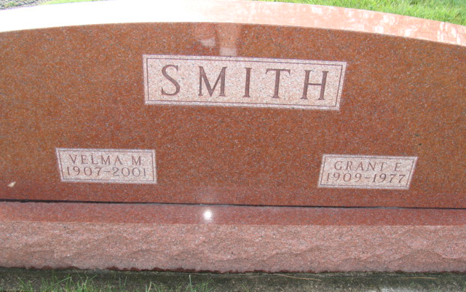
Photo by Alicia Kneuss

Grant E. Smith, 67, 5016 Goshen Rd, Fort Wayne, died at 12:35 p.m. Tuesday in a Fort Wayne nursing home. Death followed a long illness and he had been in poor condition for several months.
Mr. Smith was a native of Berne and was born here, the son of O.N. and ?? Heller Smith. He was a graduate of Berne High School and in the 1920’s a prominent athlete in both basketball and baseball. He was one of the community’s outstanding pitchers, both in high school and for several years afterwards. Associated with Smith Brothers Furniture Company of this city for many years, he was president of the firm several years and a sales representative for a long period.
Thirteen years ago Mr. and Mrs. Smith moved to Fort Wayne where Mr. Smith operated Grant’s Fireside Furniture Store for a number of years. Mr. Smith was a member of the Wallen United Methodist Church in Wayne, the Shriners, Elks and Moose Lodge F & AM 689 Huntertown.
Survivors include his wife, the former Velma Opliger; three daughters, Mrs. David (Carolyn) Schwartz of New Haven, Mrs. Nancy Siebert of Tenn., and Mrs. Bette ???, Overland Park, Kan.; one son, ?? (Dick) Smith, Clearwater, Fla.; and a stepmother, Mrs. Pearl Smith, Berne. There are nine grandsons and granddaughters. Services will be at 1 p.m. Friday at D.O. McComb & Sons Funeral Home in Fort Wayne. Calling will be from 2 to 5 and 7 to 9 Thursday. Graveside services will take place at M.R.E. Cemetery, Berne, at 12:00 noon Friday.

Date of Death: November 13, 1977; Date of Burial: November 15, 1977

Berne (IN) Library Heritage Room
1973-1984 MRE Obit Book, image #164

