Gloria (Aungst) Smith
September 24, 1959 – April 28, 2023

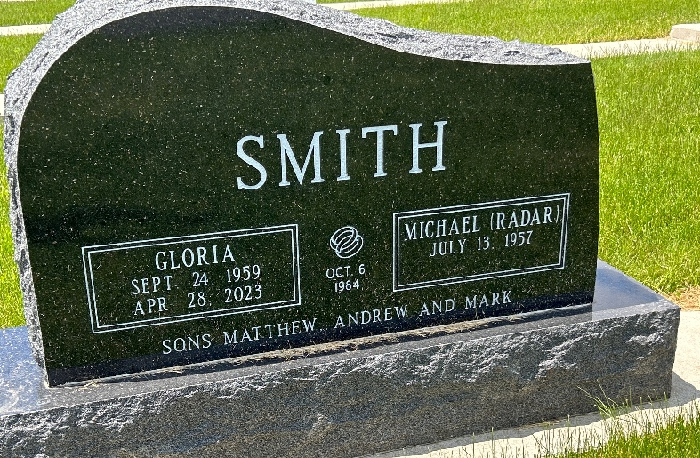
Photo by Barbara Baker Anderson

Gloria A. Smith, 63, of Berne, Indiana entered into the arms of our Heavenly Father on Friday afternoon, April 28, 2023, at Adams Memorial Hospital following an unexpected medical event.
She was born to Burnell Aungst and Jean (Beiswanger) Aungst on September 24, 1959, in Kendallville, Indiana. Gloria and Michael H. “Radar” Smith were united in marriage on October 6, 1984, in Kendallville, Indiana their faith in God was the foundation upon which their marriage was built.
Gloria's faith was the cornerstone of her life, as she was an active member of First Missionary Church in Berne, where she served the Lord with a joyful heart. Gloria was instrumental in helping with MUM's and Sunday School, sharing her love for the Lord with generations of young believers. Gloria's devotion to her faith extended beyond the walls of her church. She volunteered at The Hope Clinic, where she was instrumental in the lives of many.
She graduated from Purdue University with a degree in Nursing, dedicating her life to service to others. As a registered nurse, Gloria dedicated over 30 years of her life to caring for others at Bluffton Regional Medical Center and also residents of Swiss Village in Berne before retiring.
As a grandmother, Gloria's love knew no bounds. She cherished every moment spent with her grandsons, who brought her immense joy and happiness. As a mother, Gloria's tender-hearted nature shone brightly in her unwavering love and support for her three red-headed boys. Her love for her family was a testament to her faith. Her love for the outdoors was evident in her passion for flowers and gardening. She found solace in nurturing and tending to her garden with the same care and attention she gave to her patients and her family. She found beauty in flowers of all the seasons. Gloria enjoyed the company of friends, sharing laughter, and creating memories. Her kind and loving nature attracted many, and her faith-filled life was an inspiration to all who knew her.
Gloria is survived by her husband, Radar Smith of Berne, Indiana; son, Matthew (Kristy) Smith of Berne, Indiana; son, Andrew (Shauna) Smith of Berne, Indiana; son, Mark Smith of Berne, Indiana; brother, Tony Aungst of Kendallville, Indiana; sister, Betty Aungst of Kendallville, Indiana; and two grandsons, Jude, and Nolan Smith.
A funeral service to celebrate the life of Gloria will be held at 10:30 a.m. Wednesday, May 3, 2023, at First Missionary Church in Berne, Indiana with Pastor Rick Schwartz and Pastor Dathan Foust officiating. Burial will follow at M.R.E. Cemetery of rural Berne, Indiana. The family will receive friends from 2:00 to 8:00 p.m. Tuesday, May 2, 2023, at First Missionary Church in Berne and also one hour prior to the service on Wednesday.
Memorials given in Gloria’s memory can be made to The Hope Clinic or First Missionary Church.

Zwick & Jahn Funeral Home, Adams County, Indiana
April 30, 2023

