Emma Matilda (Bixler) Smith
April 20, 1889 – June 23, 1972

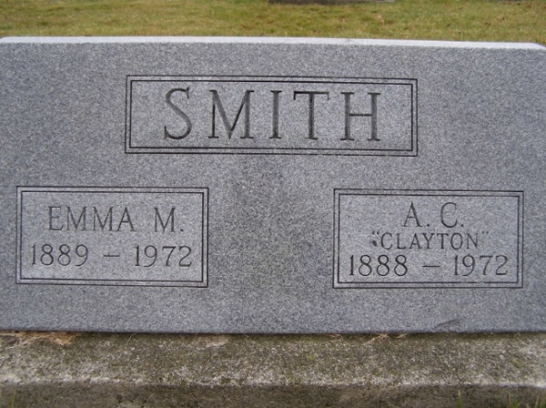
Photo by Shaunda Bedwell Opdycke

Funeral For Mrs. A. C. Smith Is Held Today
Local Woman, 83, Dies at Berne Nursing Home
Services were held at 10:30 am today for Mrs. Emma Smith, 83, wife of A. C. Smith of 255 Van Buren Street. She died at the Berne Nursing Home at 7:30 am Friday, after a long illness. Mrs. Smith had been in failing health for ten years and ill for the past two months.
Rev. Homer Achor officiated at the service today and burial was in the MRE Cemetery.
Mrs. Smith was a lifelong resident of this community and was born April 20, 1889, a daughter of David and Anna Luginbill Bixler. She was married to A. Clayton Smith April 2, 1911, in Berne.
Surviving are the husband; a son, Maurice M. Smith, Berne and three daughters, Mrs. Corrine Miller, Berne; Mrs. Roy E. (Genevieve) Strickler, Decatur and Mrs. Arthur (Joyce) Anker, Fort Wayne; seven grandchildren and 12 great-grandchildren.
Mrs. Smith was a member of the Trinity United Methodist Church where she played the organ and piano since 1912, retiring ten years ago. She was a member of the Eastern Star and a former member of the Berne Garden Club.
Mr. and Mrs. Smith observed their 61st wedding anniversary Easter Sunday, April 2. The next day Mrs. Smith was admitted to the Adams County Memorial Hospital, becoming ill before Easter. On May 8, she was transferred to the Community Care Center in Decatur and on the same day Mr. Smith was admitted to the Berne Nursing Home where he is now. Mrs. Smith was transferred to the Berne Nursing Home June 13.
Mr. and Mrs. Smith both graduated from Berne High School in 1907. Mrs. Smith then attended the Oberlin Conservatory of Music at Oberlin, Ohio. She formerly taught piano students in her home.
Mrs. Smith was the last survivor in her family. Preceding her in death were Mrs. Clara Reusser, Mrs. Esther Winteregg, Dr. Ermin D. Bixler, Laura Rinder, Mary Moss, Dr. Noah A. Bixler, Frank Bixler and one brother in infancy.

Date of Death: June 23, 1972; Date of Burial: June 26, 1972; Burial: MRE

Berne (IN) Library Heritage Room
MRE Obit Book 1966-1972
**

Emma Smith, 83, taken by death

Mrs. Emma Smith, 83, wife of A.C. Smith of 255 Van Buren street, Berne, died at 7:30 p.m. Friday at the Berne nursing home. She had been ill since April.
A lifelong resident of Berne, she was born April 20, 1889, to David and Anna Luginball-Bixler, and was married to A.C. Smith April 2, 1911. Mrs. Smith was a member of the Trinity United Methodist church at Berne, serving as organist since 1912, and was a member of the Order of Eastern Star.
Surviving are her husband, three daughters, Mrs. Roy (Genevieve) Strickler of Decatur, Mrs. Corinne Miller of Berne, and Mrs. Arthur (Joyce) Anker of Fort Wayne; one son, Maurice M. Smith of Berne; seven grandchildren and 12 great-grandchildren. She was preceded in death by fur sisters and here brothers, including Dr. Noah Bixler of Decatur.
Services will be held at 10:30 am Monday at the Yager funeral home in Berne, with Rev. Homer W. Achor officiating. Burial will be in MRE cemetery. Friends may call at the funeral home after 2 p.m. Sunday.

Decatur Daily Democrat, Adams County, Indiana
Saturday, June 24, 1972

