Elmer Joe Smith
December 22, 1932 – March 3, 2015

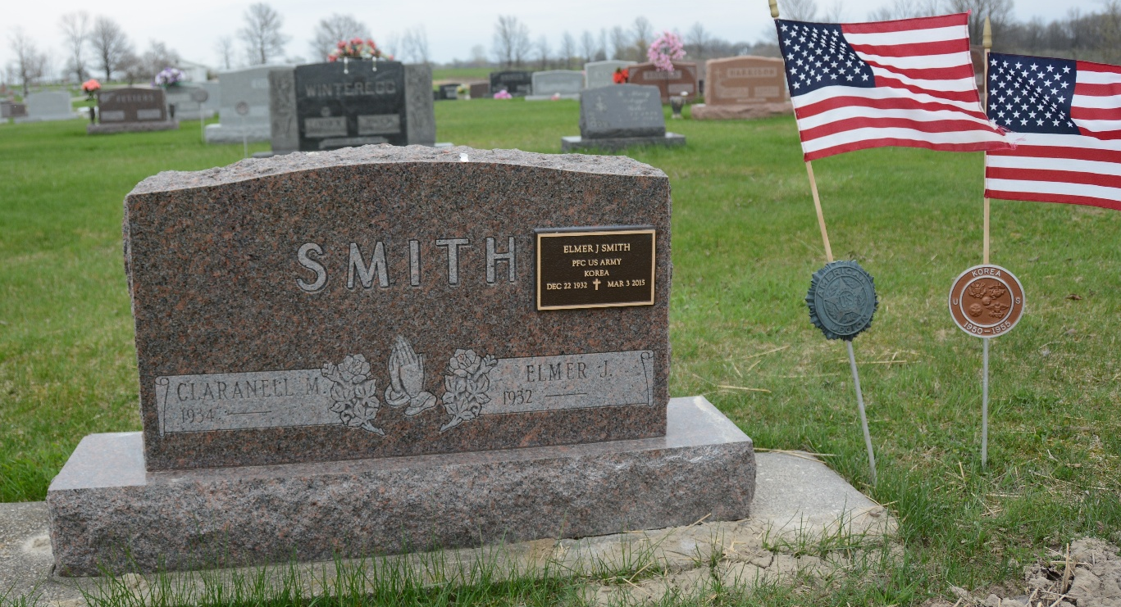
Photo by Deb Curry

Elmer J. Smith, 82, Berne, passed away unexpectedly on March 3, 2015 after a fall on the ice at his work at McDonalds in Berne. He was born to Rev. Elmer F. and Edith (Smith) Smith in South Bend, IN. He married Claranell Sprunger on June 8, 1956.
Elmer was a member of the Trinity United Methodist Church where he was an usher and operator of the sound system for many years. He was employed at the G.E. Company in Decatur for 35 years and later at Berne McDonalds in the maintenance department for 17 years. He also served in the U.S. Army in the Korean Conflict. Elmer enjoyed camping and watching his grandchildren in their sports activities.
Survivors include his wife, Claranell, 2 sons; Mark (Lisa) Smith of Berne, Paul Smith of Henderson NV, daughters; Karla (Jeff) Farris of Berne, Wanda (Dave) Johnson of Fort Wayne, 7 grandchildren and 4 great-grandchildren.
Preceding in death is a son, Terry Smith, brother, Gerald Smith and sisters; Pauline Dietrich and Dorcas Smith.
Funeral services are Saturday, March 7, 2015 at 10:30 am at the Trinity United Methodist Church in Berne with visitation 1 hour prior to the services. Visitation also Friday from 3 to 8 pm at the Yager-Kirchhofer Funeral Home. Officiating is Pastor Mark Harris. Burial is in the MRE Cemetery.
Preferred memorials are to the Trinity United Methodist Church &/or Dots in Blue.

Yager-Kirchhofer Funeral Home, Adams County, Indiana
March 9, 2015

