Elmer F. Smith, Rev.
September 26, 1892 – October 6, 1958

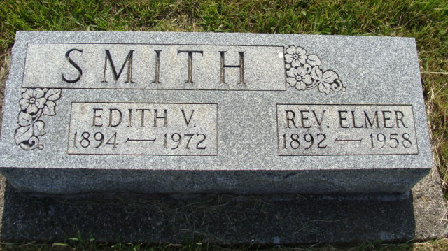
Photo by Alicia Kneuss

REV. ELMER SMITH

Rev. Elmer Smith of Berne, sixty-six years old, died unexpectedly Monday afternoon following a cerebral hemorrhage. Rev. Mr. Smith was a former minister of Salem Evangelical United Brethren church in Bremen, leaving here about twenty years ago.
He is survived by his widow; two sons, Gerald Smith of Bremen and Elmer Joe Smith of Berne; and two daughters, Mrs. Verne Dietrich of Naperville, Ill., and Miss Dorcas Smith of Richmond.
Funeral services will be held this afternoon, oct. 9, at two o’clock at Berne.

The Bremen Enquirer, Marshall County, Indiana
Thursday, October 9, 1958
**

Indiana, U.S., Death Certificates, 1899-2017

Name Reverend Elmer F. Smith
Gender Male
Race White
Marital Status Married
Age 66
Birth Date 26 Sep 1892
Birth Place Ohio
Death Date 6 Oct 1958
Death Place Decatur, Adams, Indiana, USA
Death Registration Date 1958
Father William H. Smith
Mother Josephine Stedcke
Informant Mrs. Edith Smith, wife
Burial 10/9/1958 M.R.E. Cemetery

