Drucilla Isabel (Kern) Smith
June 15, 1861 – December 30, 1920

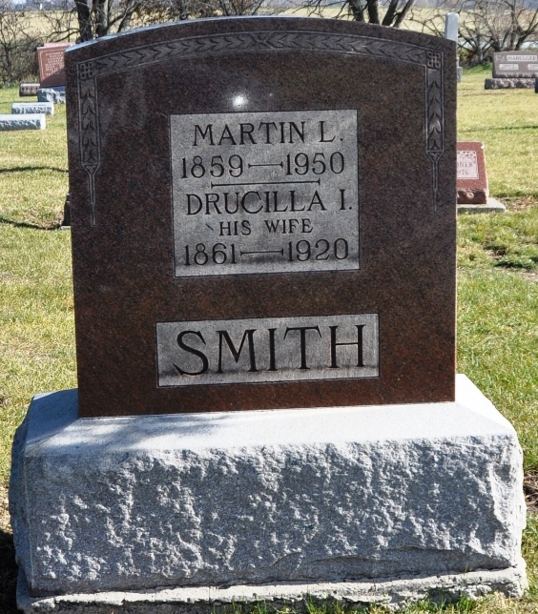
Photo by Shaunda Bedwell Opdycke

Indiana, U.S., Death Certificates, 1899-2017

Name Ducilla Isabel Smith
[Ducilla Isabel Kern]
Gender Female
Race White
Marital Status Married
Age 59y 6m 15d
Birth Date 15 Jun 1861
Birth Place Adams County, Indiana
Death Date 30 Dec 1920
Death Place Berne, Adams, Indiana, USA
Death Registration Date 1920
Father Philip B Kern
Mother Mary E. Luckey
Spouse Martin L Smith, informant
Burial MRE 1-2-1921

