Dasie A. (Girod) Smith
June 24, 1901 – April 9, 2005

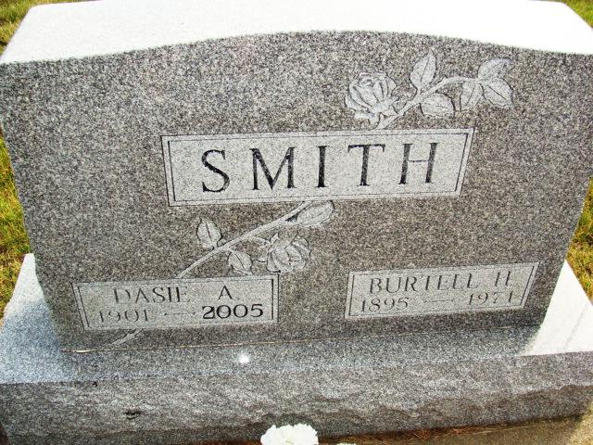
Photo by Alicia Kneuss

DAISIE A. SMITH, 103, of Fort Wayne, died Saturday, April 9, 2005, at Renaissance Village, where she resided. Born June 24, 1901, in Adams County, she was a homemaker. She was a member of Grace St. John's United Church of Christ, Fort Wayne. Survived by one son, Glen (Dorothy) Smith of Fort Wayne; eight grandchildren; and 19 great-grandchildren. She was preceded in death by her husband, Burt Smith, in 1971; daughter, Lois Kizer, in 2002; three sisters; and three brothers. Service is 10 a.m. Wednesday at D.O. McComb & Sons Lakeside Park Funeral Home, 1140 Lake Ave. Calling is from 2 to 5 and 7 to 9 p.m. Tuesday at the funeral home. Burial at M.R.E. Cemetery, Berne. In lieu of flowers, memorials may be made to Grace St. Johns United Church of Christ or Worship for shut-ins.
News-Sentinel, The (Allen County, Indiana
April 11, 2005
**
DAISIE A. SMITH, 103, of Fort Wayne, died Saturday, April 9, 2005, at Renaissance Village, where she resided. Born June 24, 1901, in Adams County, she was a homemaker. She was a member of Grace St. John's United Church of Christ, Fort Wayne. Survived by one son, Glen (Dorothy) Smith of Fort Wayne; eight grandchildren; and 19 great-grandchildren. She was preceded in death by her husband, Burt Smith, in 1971; daughter, Lois Kizer, in 2002; three sisters; and three brothers. Service is 10 a.m. Wednesday at D.O. McComb & Sons Lakeside Park Funeral Home, 1140 Lake Ave. Calling is from 2 to 5 and 7 to 9 p.m. Tuesday at the funeral home. Burial at M.R.E. Cemetery, Berne. In lieu of flowers, memorials may be made to Grace St. Johns United Church of Christ or Worship for shut-ins.
Journal Gazette, The (Fort Wayne, Indiana)
April 11, 2005

