Daniel Martin Smith
December 12, 1947 – November 19, 1952

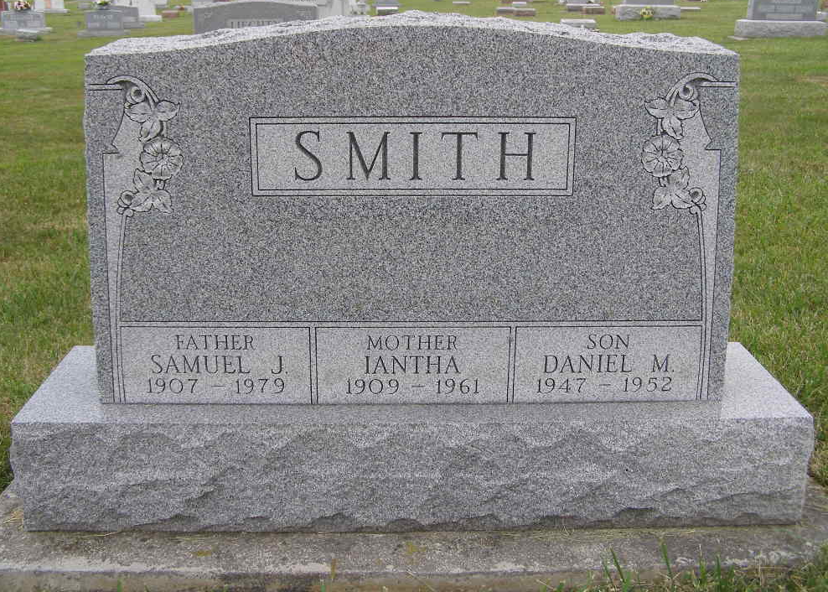
Photo by Shaunda Bedwell Opdycke

MONROE WOMAN'S GRANDSON DROWNS
DANIEL SMITH, 5, DROWNS IN CISTERN AT ??
(Missing) lad was a nephew of the late Otto Smith, well known aviator of a number of years ago, and has many relatives in Adams County.
(Missing) The boy's little body was found in the water but he had been dead for some time. The water was about seven feet deep.
The Smith family is remembered by many local people. The lad was buried on the Simon Smith burial lot.
Adams County, Indiana Historical Museum
1952Sep-Dec1953 Scrapbook, Image 65
**
Indiana, U.S., Death Certificates, 1899-2017
Name Daniel Martin Smith
Gender Male
Race White
Age 5
Birth Date 12 Dec 1947
Birth Place Indiana
Death Date 19 Nov 1952; accidental drowning
Death Place Rural, Steuben, Indiana, USA
Death Registration Date 1952
Father: Samuel J Smith
Mother: Iantha Tyler
Informant: Samuel Smith, LaGrange, Indiana
Burial: November 23, 1952; MRE Cemetery; Berne, Indiana

