Daniel Smith
February 5, 1872 – March 19, 1944

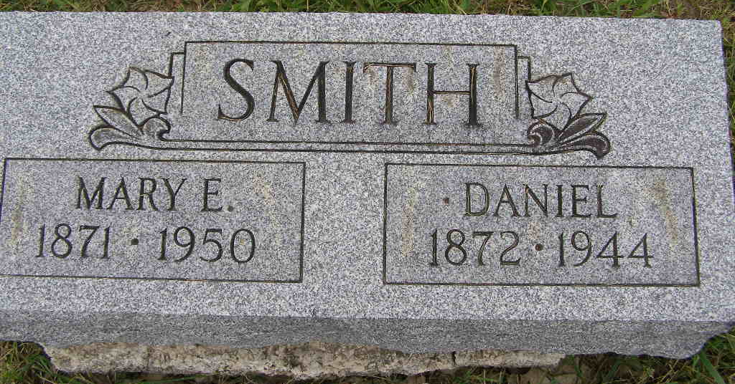
Photo by Shaunda Bedwell Opdycke

Indiana, U.S., Death Certificates, 1899-2017

Name Daniel Smith
Gender Male
Race White
Marital Status Married
Age 72y 1m 14d
Birth Date 5 Feb 1872
Birth Place Adams, Co.
Death Date 19 Mar 1944
Death Place Rural, Allen, Indiana, USA
Death Registration Date 1944
Father John Smith b. Switzerland
Mother Barbara Gortner b. Switzerland
Spouse Mary Smith, age 72
Informant Mrs. Mary E. Smith
Burial 3/22/1944 M.R.E.

