Colleen Faye (Liechty) Smith
August 10, 1934 – June 12, 2001

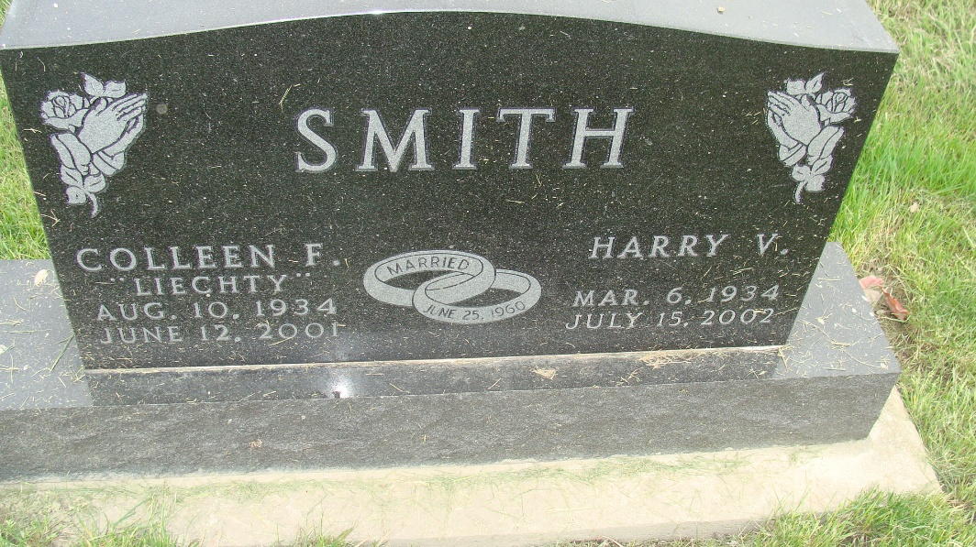
Photo by Alicia Kneuss

Colleen Faye Smith, 66, of Berne, a member of First Missionary Church, died Tuesday, June 12, 2001, at Adams County Memorial Hospital in Decatur. The Adams County native worked at Kohl's Department Store in Fort Wayne at the service desk for 15 years.
Surviving are her husband, Harry; a son, Matthew S. of Fort Wayne; daughters Lori Gerdes and Amy J. Bertsch, both of Berne, and Debra Gerber of Decatur; brothers Melvin E. and Loren L. Liechty, both of Berne, and the Rev. Robert Liechty Jr. of Lima, Ohio; sisters Anna A. Roop and Berneta L. Lehman, both of Berne; seven grandchildren; and one great-grandchild. She was preceded in death by three brothers and a sister.
Services are 2 p.m. Friday at Haggard & Sefton Funeral Home, Decatur, with calling from 2 to 5 and 6 to 8 p.m. Thursday. Burial will be at MRE Cemetery, Berne. Memorials are to the family. Information provided by Haggard and Sefton Funeral Home, Decatur, 1-219-724-7167.

News-Sentinel, The (Allen County, Indiana)
Wednesday, June 13, 2001

